Customer Review Helpfulness Analytics Platform

Project Overview:-
This project implements a modern, cloud-native data engineering pipeline on Microsoft Azure to analyze customer review helpfulness for an e-commerce platform. The solution combines both batch and simulated real-time data ingestion, processes the data using Azure Databricks and PySpark, and delivers curated, analytics-ready datasets for reporting and business intelligence.
The pipeline follows a scalable and reliable architecture, enabling organizations to monitor review quality, identify helpful feedback patterns, and gain actionable insights through interactive Power BI dashboards.

Objectives:-
- Ingest historical customer review data into Azure Data Lake Storage Gen2 using Azure Data Factory.
- Simulate real-time customer review ingestion through Azure Event Hubs.
- Implement a layered data architecture (Raw, Processed, and Curated) within Azure Data Lake Storage Gen2.
- Apply data cleaning, validation, deduplication, and feature engineering using PySpark in Azure Databricks.
- Generate derived metrics such as review length, word count, helpfulness bands, and review quality indicators.
- Load curated data into Azure SQL Database to support analytical querying and reporting.
- Develop interactive Power BI dashboards to visualize helpfulness trends, low-helpfulness drivers, and real-time review intake.
- Build a reliable, scalable, and maintainable data pipeline that supports both batch and streaming data processing.

Architecture Overview:-
The solution is built on Microsoft Azure using a hybrid batch and streaming architecture. Historical customer review data is ingested through Azure Data Factory, while simulated live review data is streamed using Azure Event Hubs. Both data sources are processed in Azure Databricks using PySpark, where cleansing, transformation, and feature engineering are performed. The curated data is stored in Azure SQL Database, which serves as the reporting layer for Power BI dashboards. This architecture ensures consistent processing logic across both ingestion paths while supporting scalable analytics and near real-time monitoring.
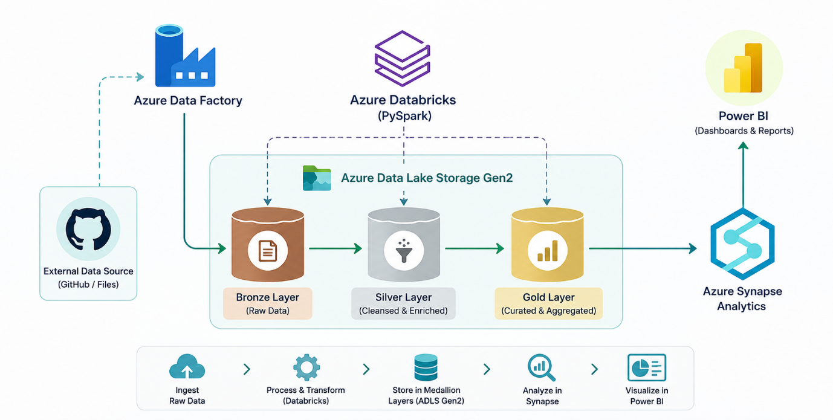

Data Flow:-
Step 1 – Ingestion
Azure Data Factory ingests the historical customer review dataset from the external source and loads it into the Raw zone of Azure Data Lake Storage Gen2. For the streaming pipeline, simulated review data is published to Azure Event Hubs, enabling continuous ingestion of incoming review records.
Step 2 – Raw Layer
The historical dataset is stored in the Raw zone of Azure Data Lake Storage Gen2 in its original format without any modifications. This layer preserves the source data for auditing, validation, and future reprocessing whenever required.
Step 3 – Processed Layer
Azure Databricks (PySpark) reads the raw data and applies data quality rules, including schema validation, null handling, text cleaning, duplicate removal, data type conversion, and feature engineering such as review length, word count, helpfulness band, and ingestion metadata. The cleaned data is written to the Processed zone.
Step 4 – Curated Layer
Further transformations aggregate and enrich the processed data to create analytics-ready datasets. Business-specific metrics and reporting tables are generated and stored in the Curated zone of Azure Data Lake Storage Gen2 using Delta format for efficient querying and reliable storage.
Step 5 – Analytics (Azure SQL Database)
The curated datasets are loaded into Azure SQL Database, which serves as the centralized reporting database. SQL queries and analytical views are created to support business reporting and dashboard development.
Step 6 – Reporting (Power BI)
Power BI connects directly to Azure SQL Database to build interactive dashboards and reports. Business users can monitor customer review helpfulness, identify low-helpfulness patterns, analyze review trends, and track incoming review quality through visual analytics.

Pipeline Summary:-
This project implements an end-to-end Azure data engineering pipeline for customer review analytics. Raw review data is ingested using Azure Data Factory, stored in Azure Data Lake Storage Gen2, and transformed in Azure Databricks using PySpark. The curated data is loaded into Azure SQL Database, which serves as the reporting layer for Power BI dashboards. The pipeline ensures reliable, scalable, and analytics-ready data for business insights.
Pipeline Flow
External Dataset → Azure Data Factory → Azure Data Lake Storage Gen2 (Raw → Processed → Curated) → Azure Databricks (PySpark) → Azure SQL Database → Power BI

Business Value:-
- Enables analysis of customer review helpfulness using a scalable cloud platform.
- Provides near real-time visibility into incoming review quality.
- Identifies characteristics of highly helpful and low-helpfulness reviews.
- Supports data-driven decisions for improving customer experience and product feedback.
- Replaces manual review analysis with an automated, reusable analytics pipeline.

Phase-1 (Bronze Layer)

Step1:- Create Resource Group.
- Create a new Azure Resource Group.
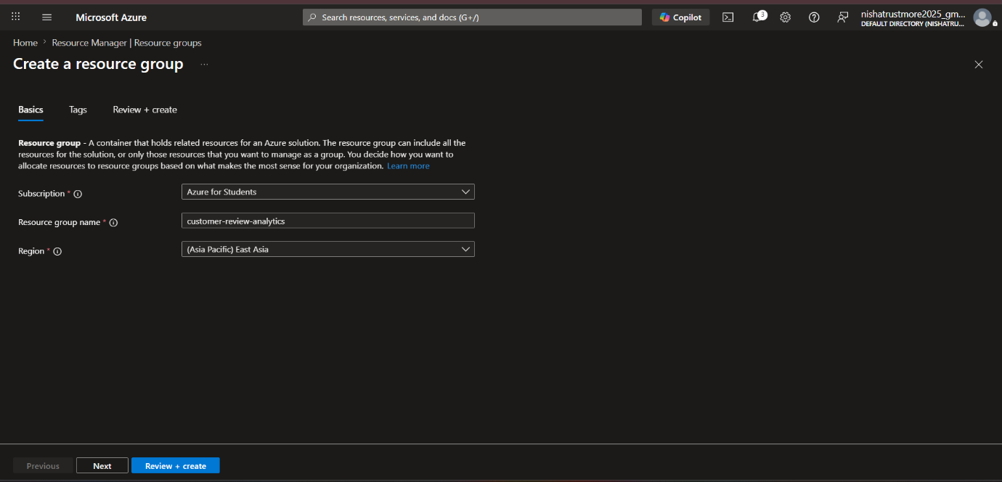

- Resource Group Name: customer-review-analytics.
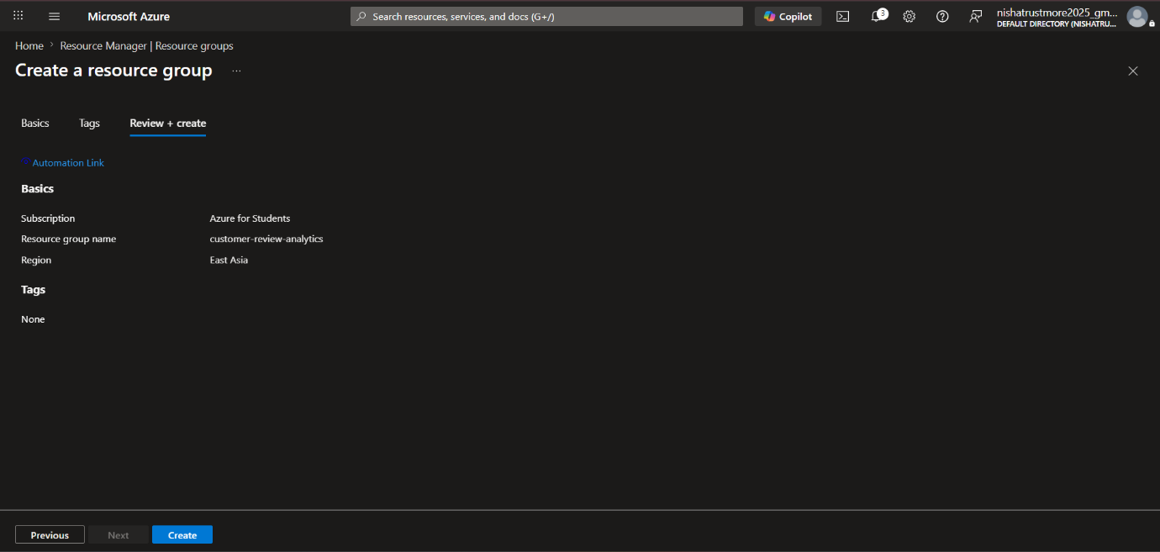

Step1:- Create Storage Account.
- Create an Azure Storage Account “stamazonreviewdldev” for storing raw data.
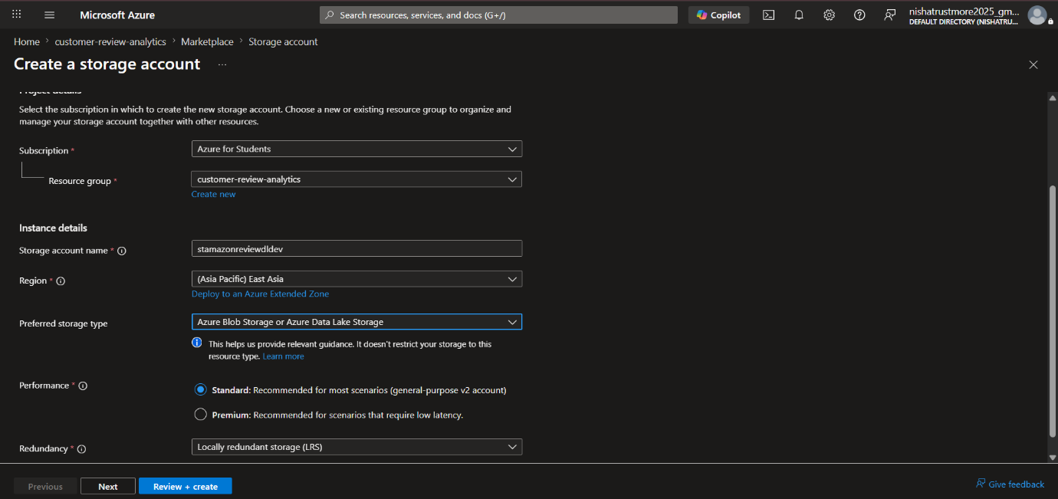

- Enabled Hierarchical Namespace to use the storage account as Azure Data Lake Storage Gen2 (ADLS Gen2).
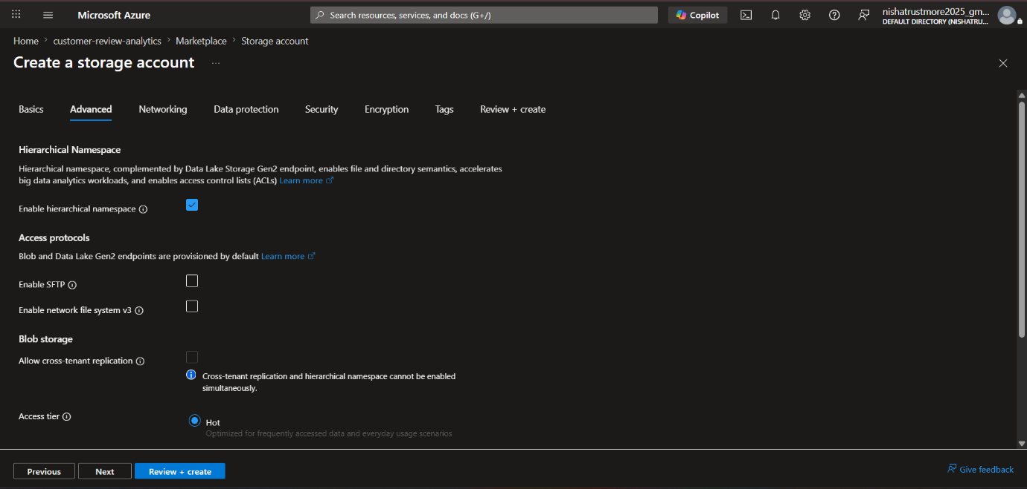

- Check Create.
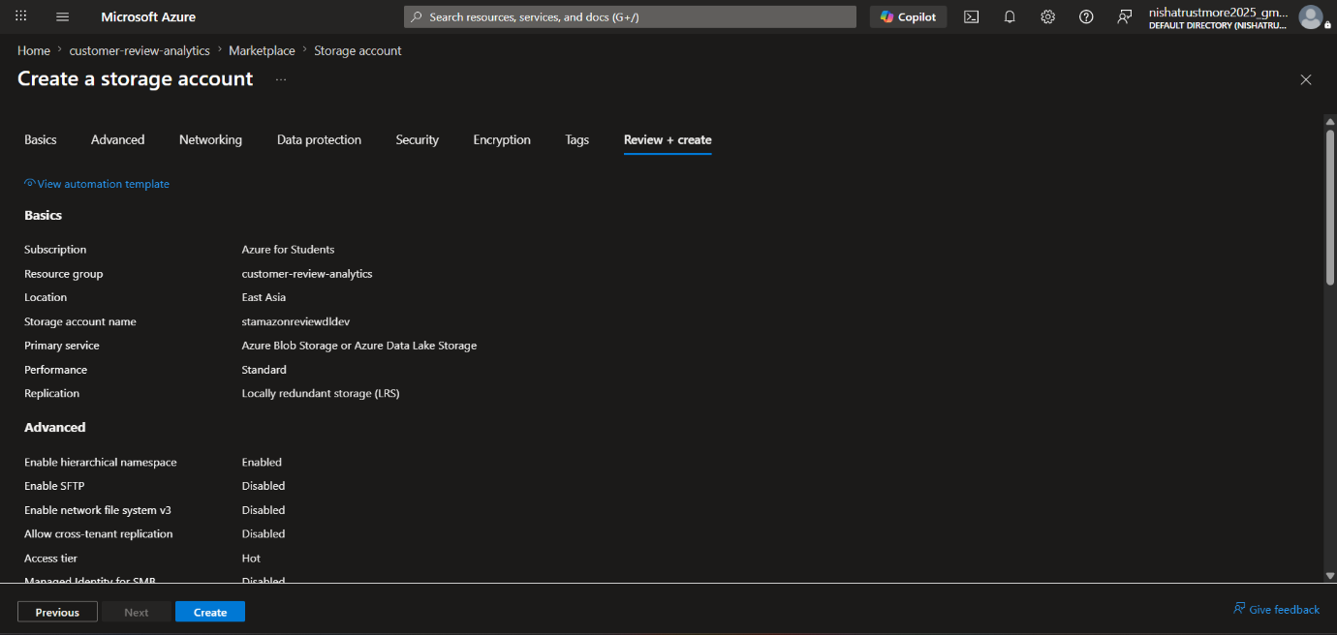

- Created Storage Account(Azure Data Lake Storage Gen2) named “stamazonreviewdldev”.
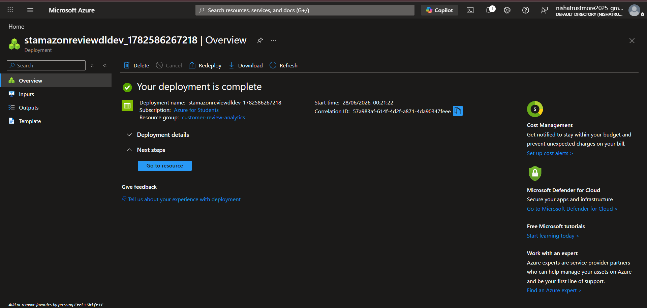

Step3:- Create Azure Data Factory
- Create Azure Data Factory named “adf-amazon-customer-review-dev”.
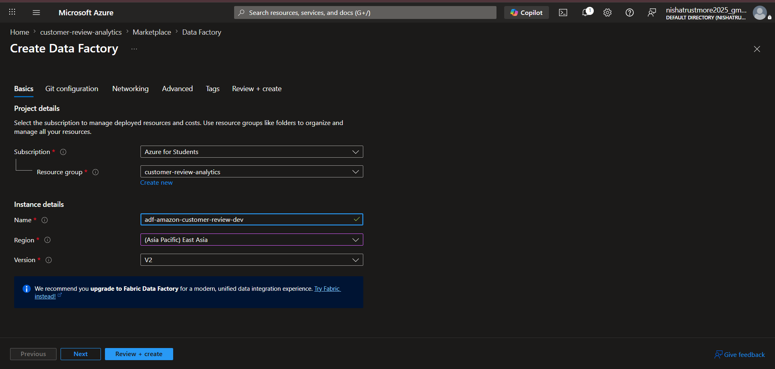

- Created Azure Data Factory named “adf-amazon-customer-review-dev”.
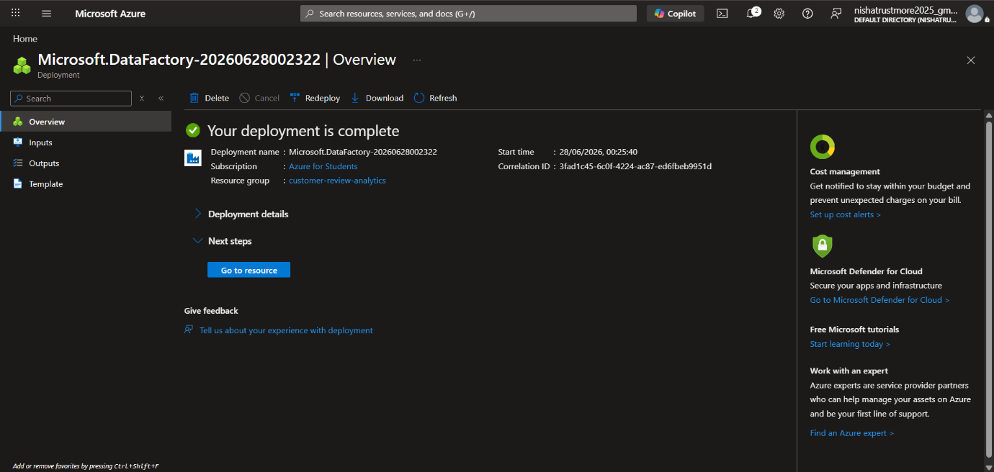

Step4: Create Containers in Azure Data Lake Storage.
- Create a container named bronze.
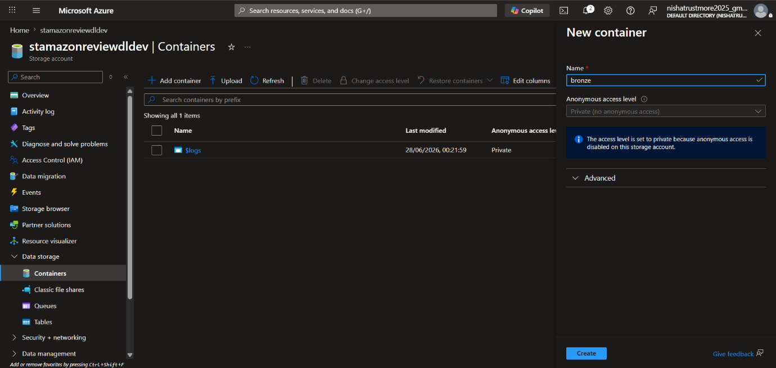

- Create a container named silver.
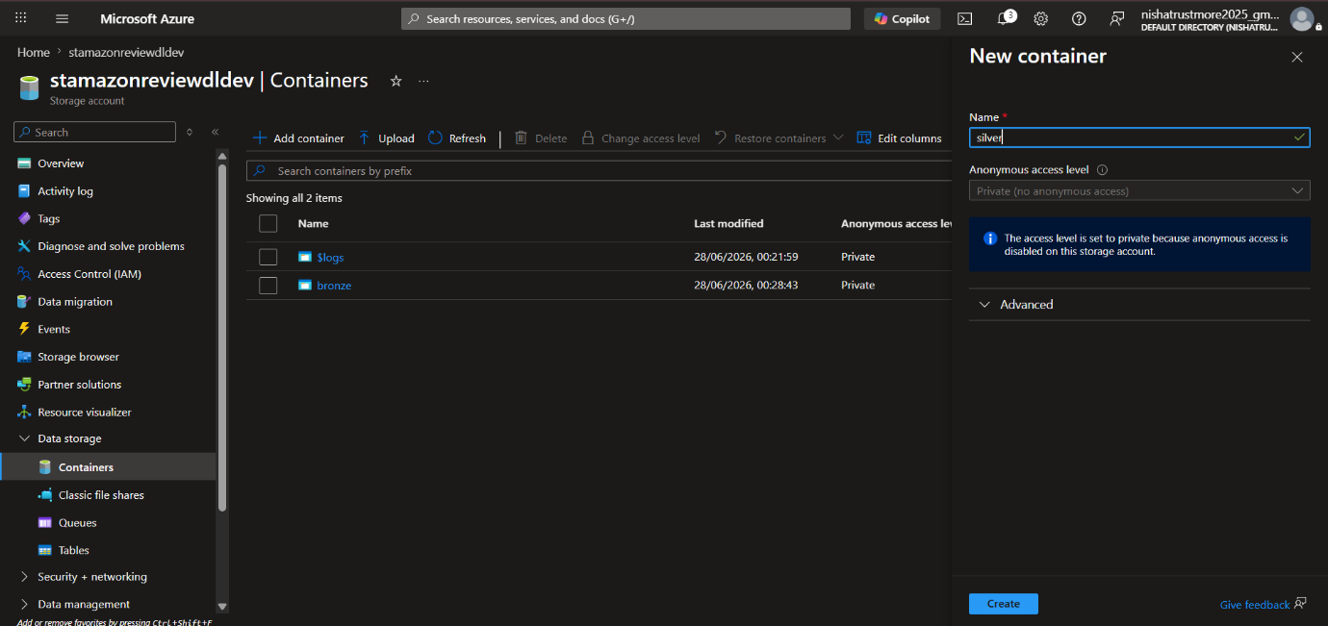

- Create a container named gold.
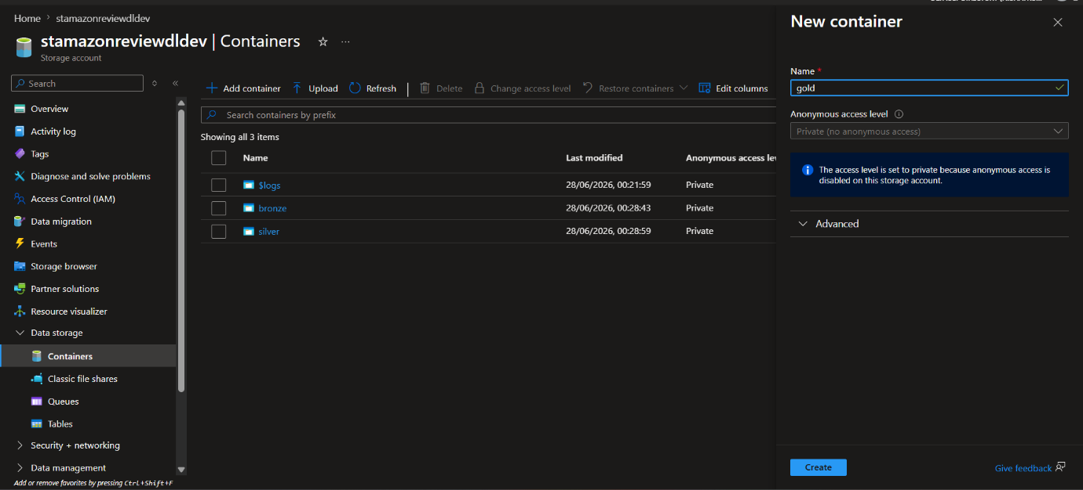

Step5:- Get Data from Source.
- Created a new pipeline name Git-To-Raw to copy raw data from the source to the bronze container.
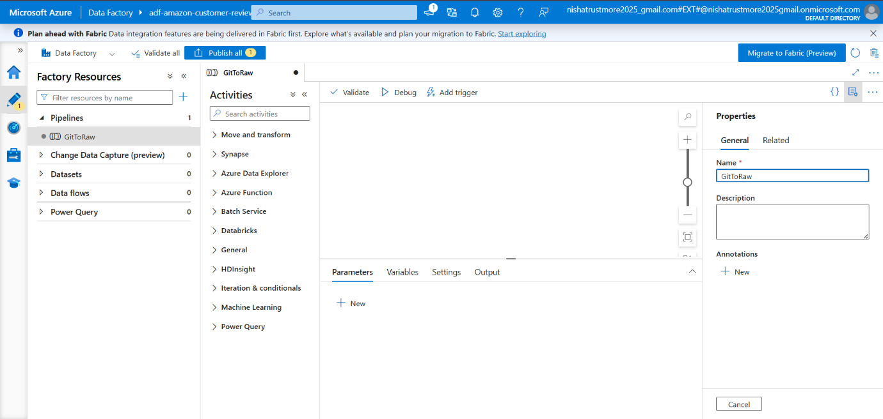

- Select Copy Activity and renamed the activity to CopyRawData.
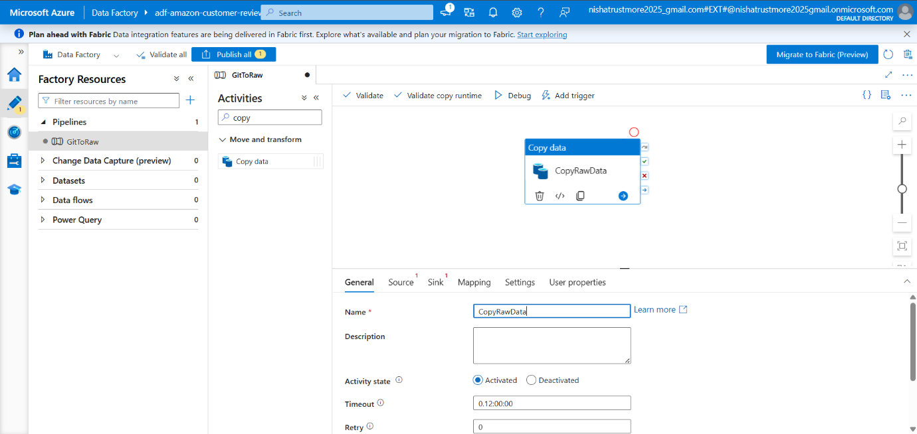

- Created an HTTP linked service named HttpLinkedService for the source dataset from the Manage tab.
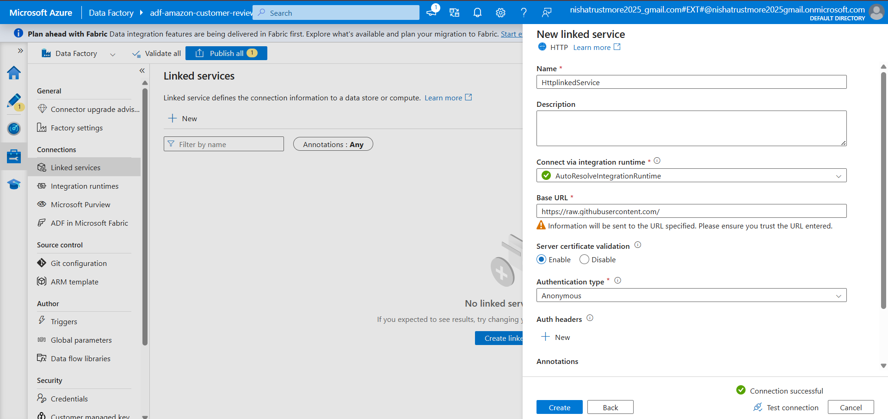

- Created an Azure Data Lake Storage Gen2 linked service named DataLakeStorage1 for the destination data lake from the Manage tab.
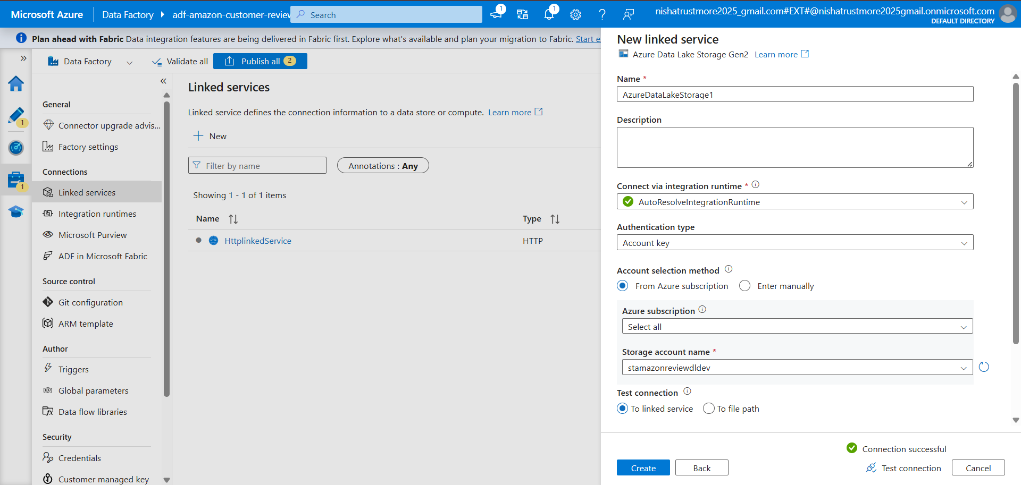

- Two liked Service has been created.
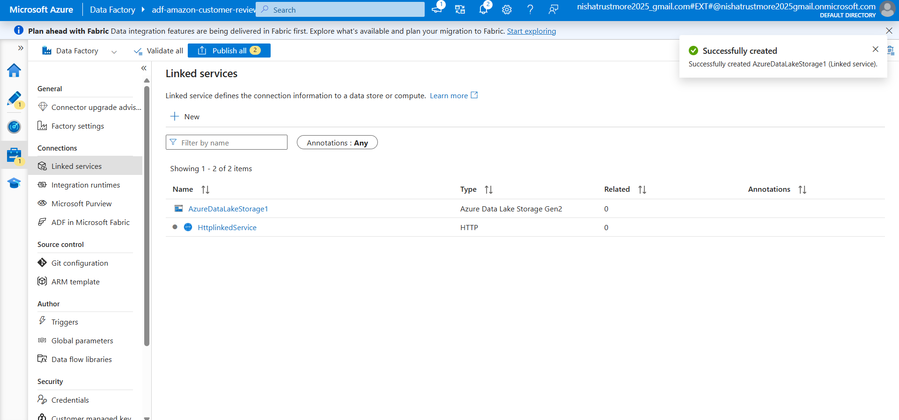

- Select the Data Store “HTTP” for Source.
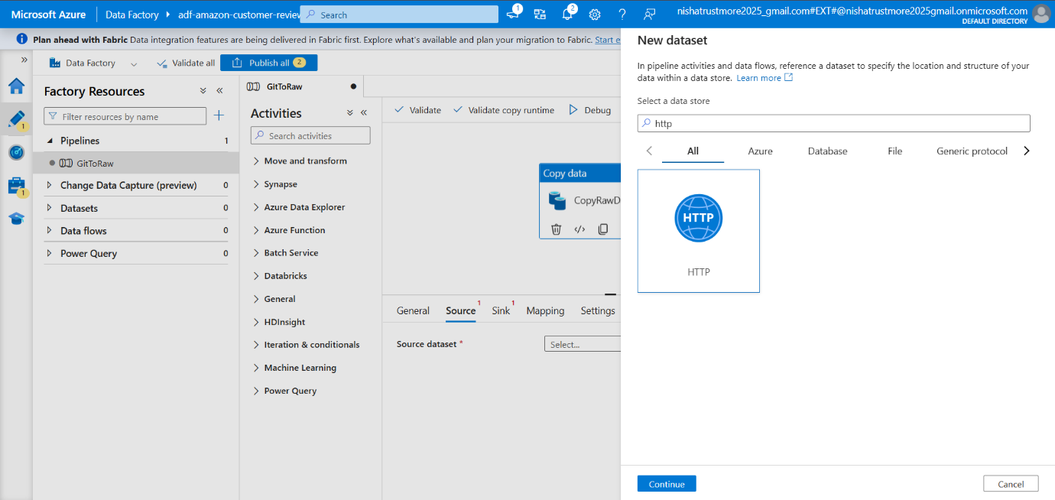

- Select the data format type “CSV”.
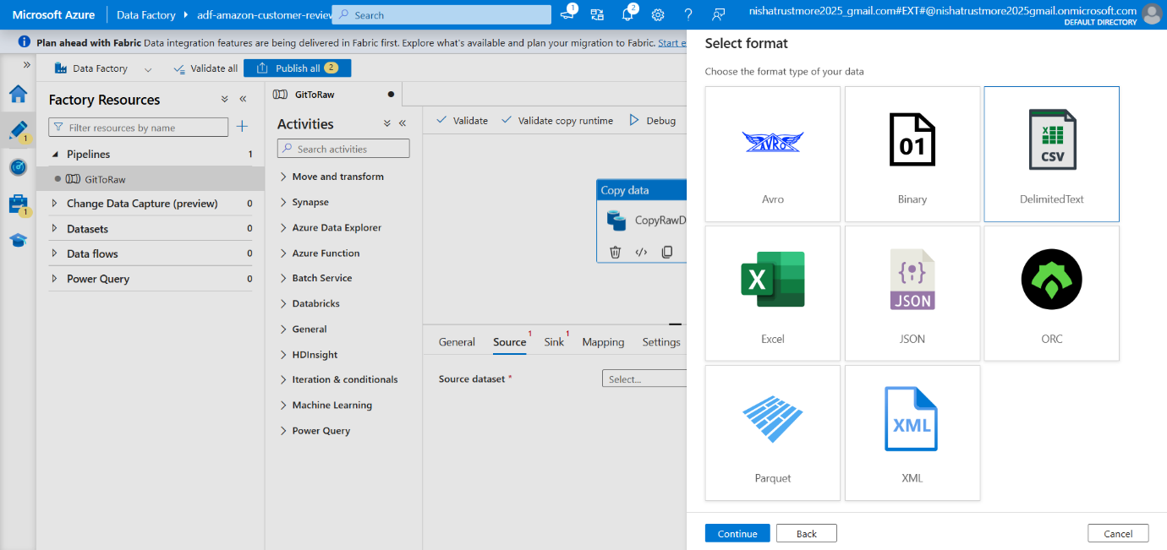

- Provide Related URL.
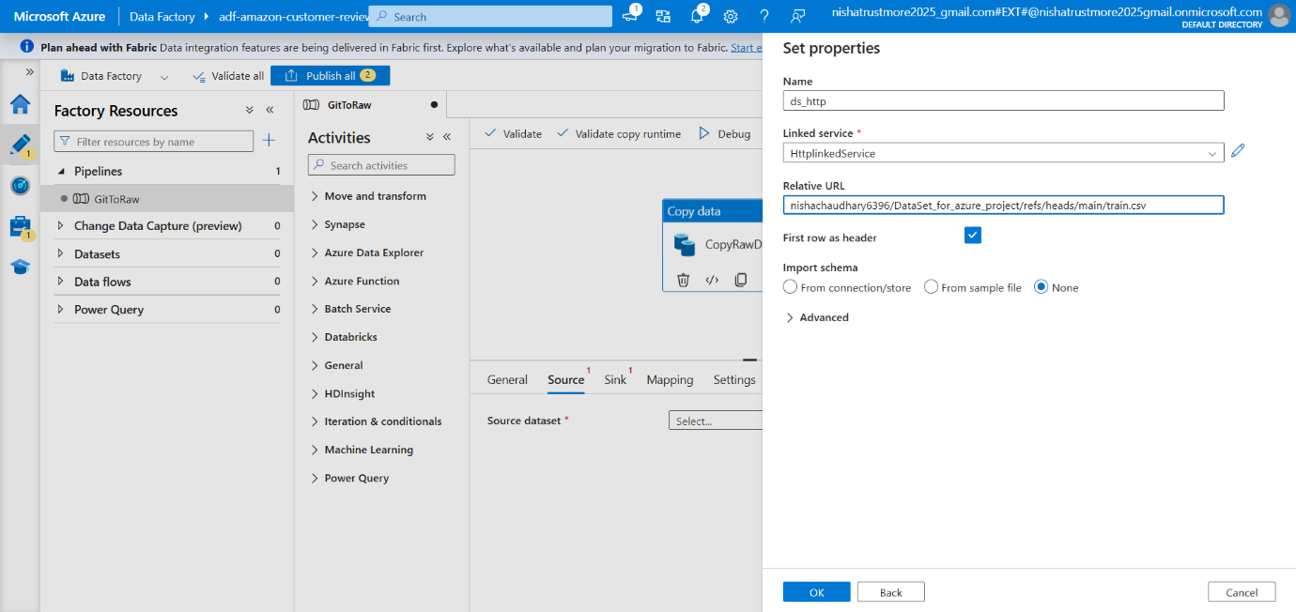

- Selected Azure Data Lake Storage Gen2 as the sink dataset.
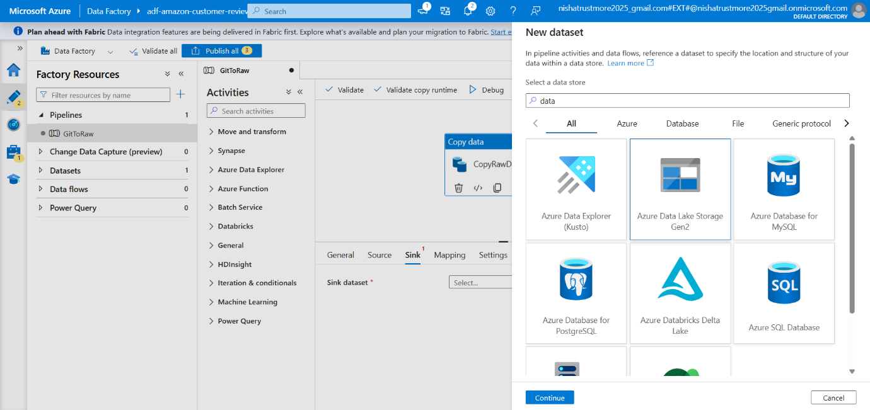

- Select the data type format “CSV”.
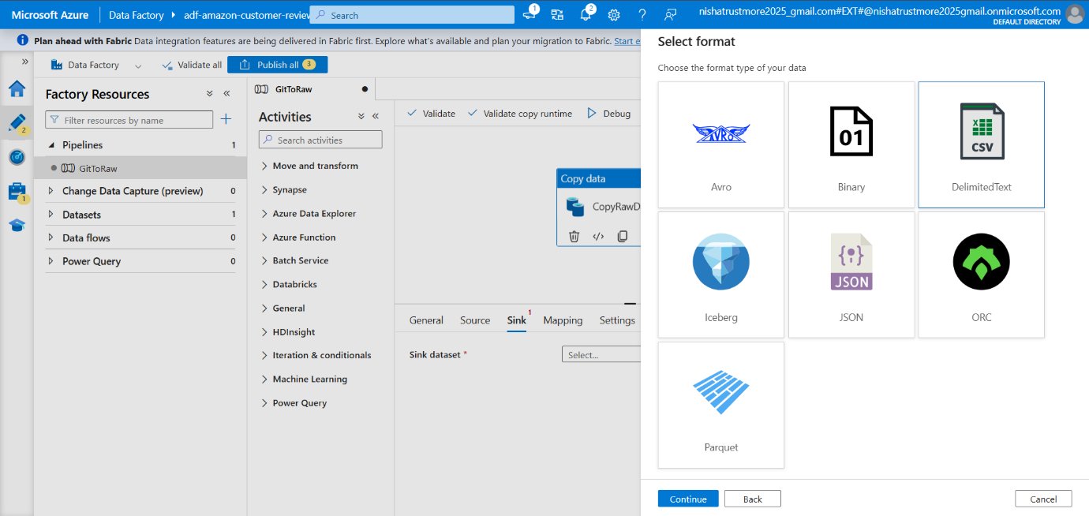

- Configured the destination path in the bronze container to store the raw data.
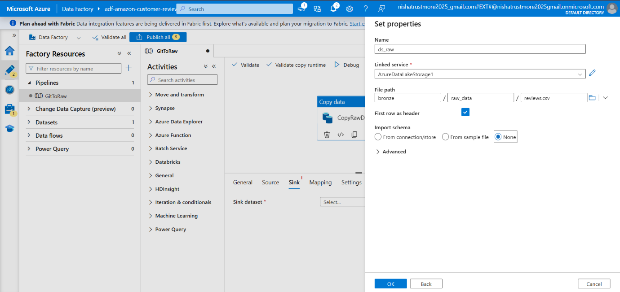

- Debug the Pipeline.
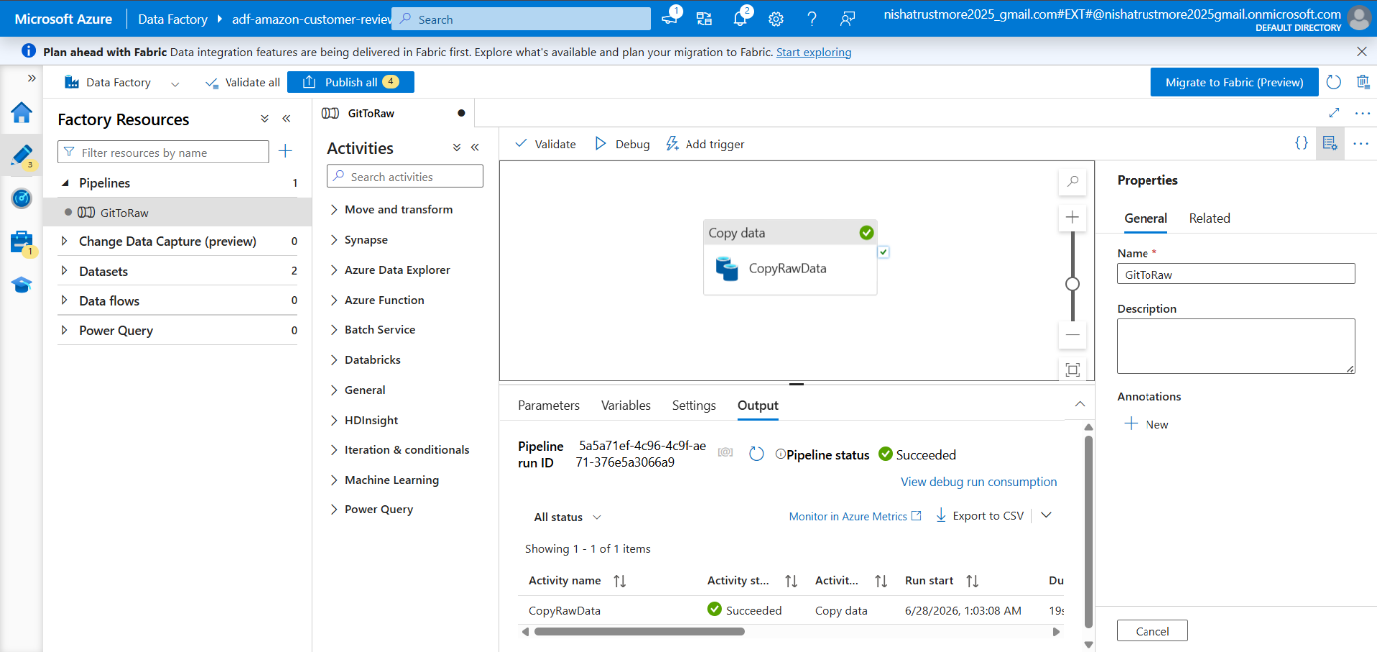

- Clicked Publish All to save and publish the pipeline and all associated resources.
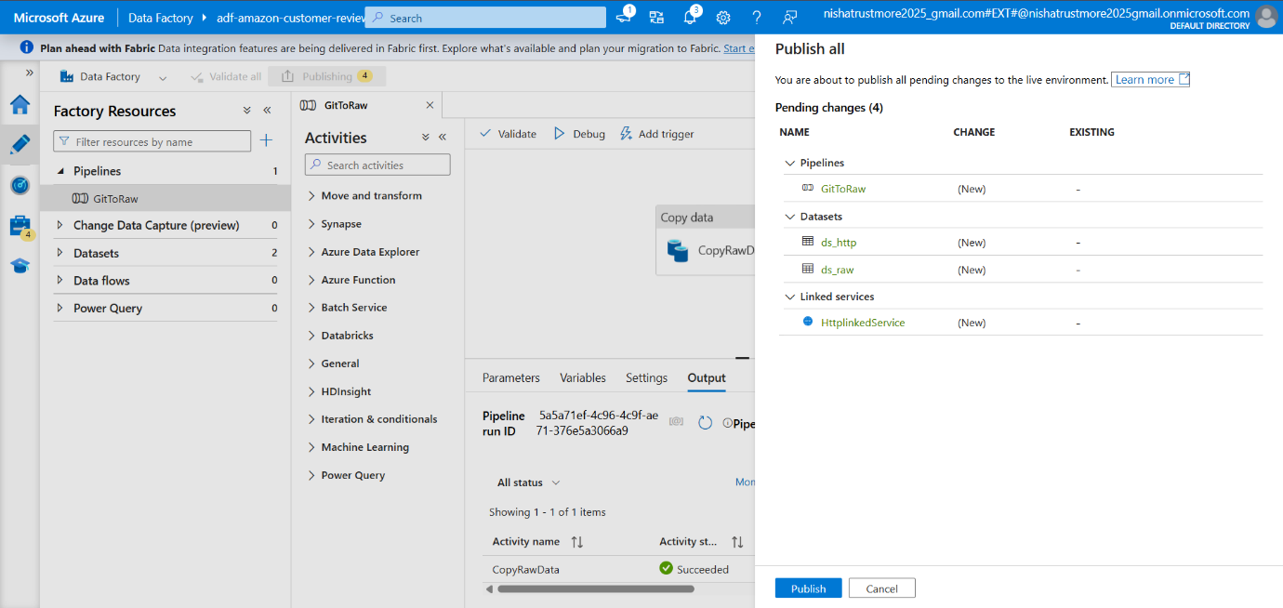

Phase 2:- (Silver Layer)

Step 1:- Create Azure Databricks
- Create an Azure Databricks Workspace.
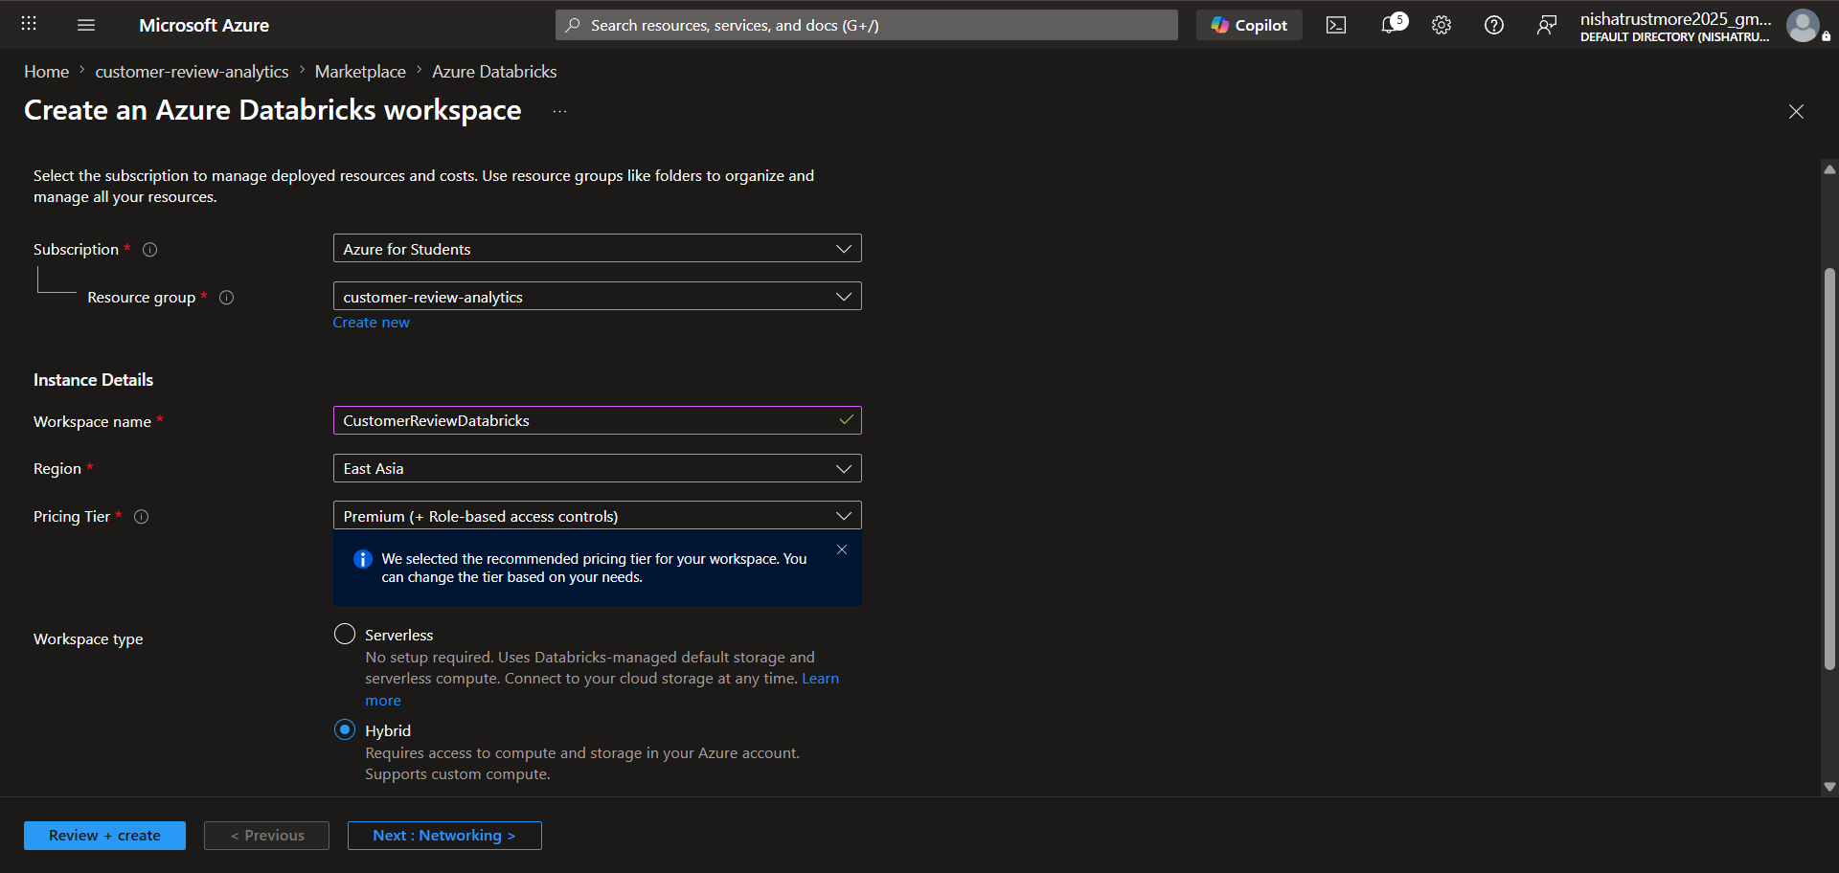

- Click Create to create Azure Databricks workspace.
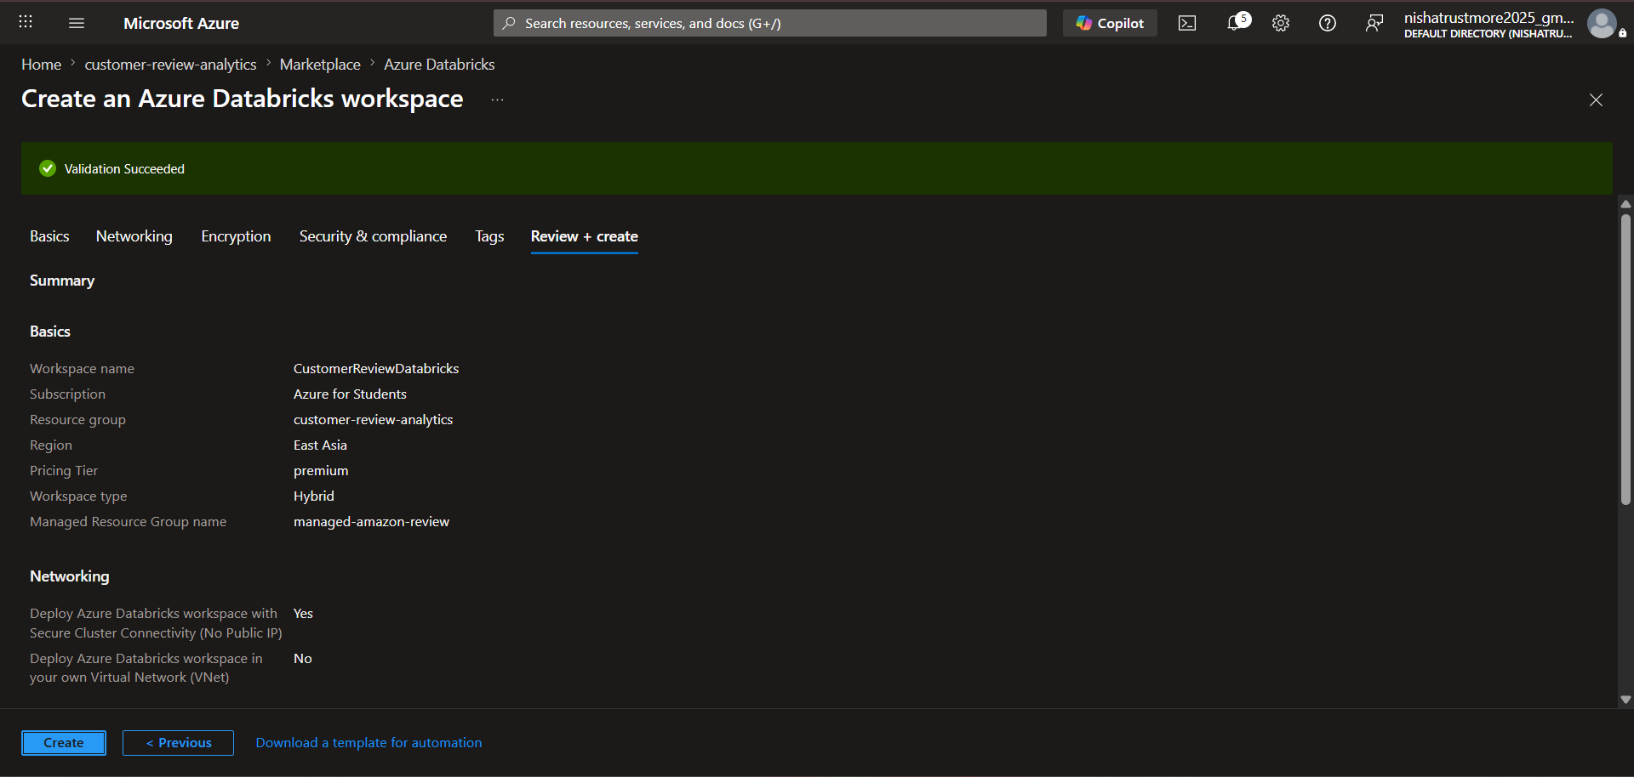

- Created Azure Databricks named CustomerReviewDatabricks.
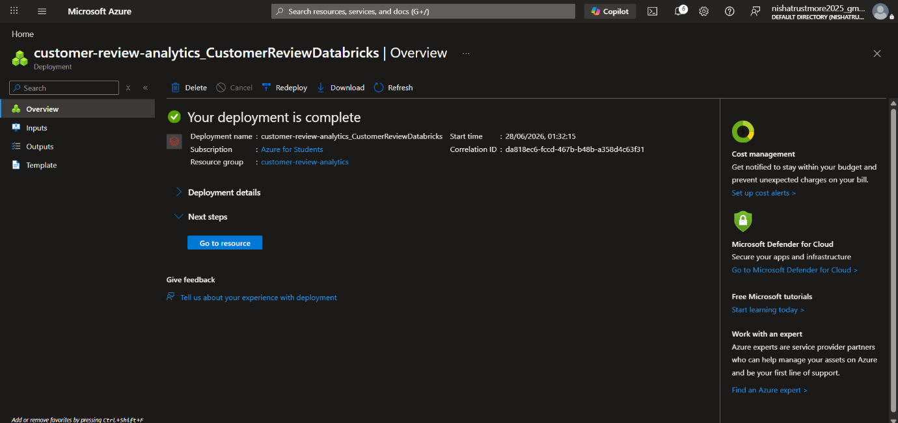

Step2:- Create new Cluster in Azure Databrick.
- Navigated to Compute, clicked Create Compute, entered the compute name “AmazonCustomerReviewCluster”, configured the General and Performance settings, and created the compute cluster.
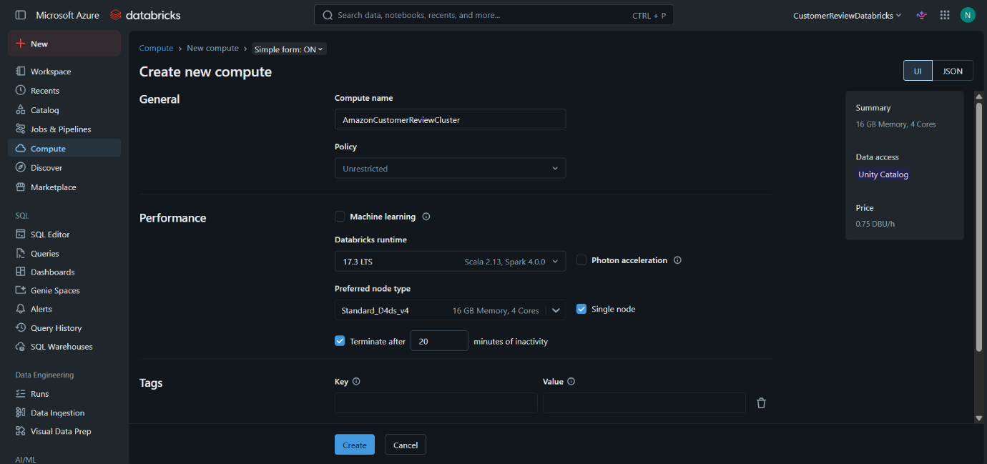

Step3:- Provide Azure Databricks with direct access to the Azure Data Lake Sorage.
- Search and Open Microsoft Entra ID.
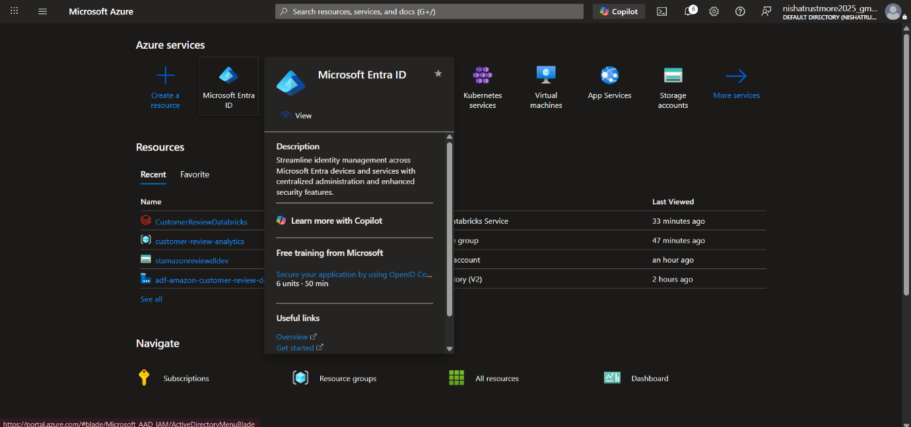

- In the Manage tab, navigated to App Registrations and created a new app registration.
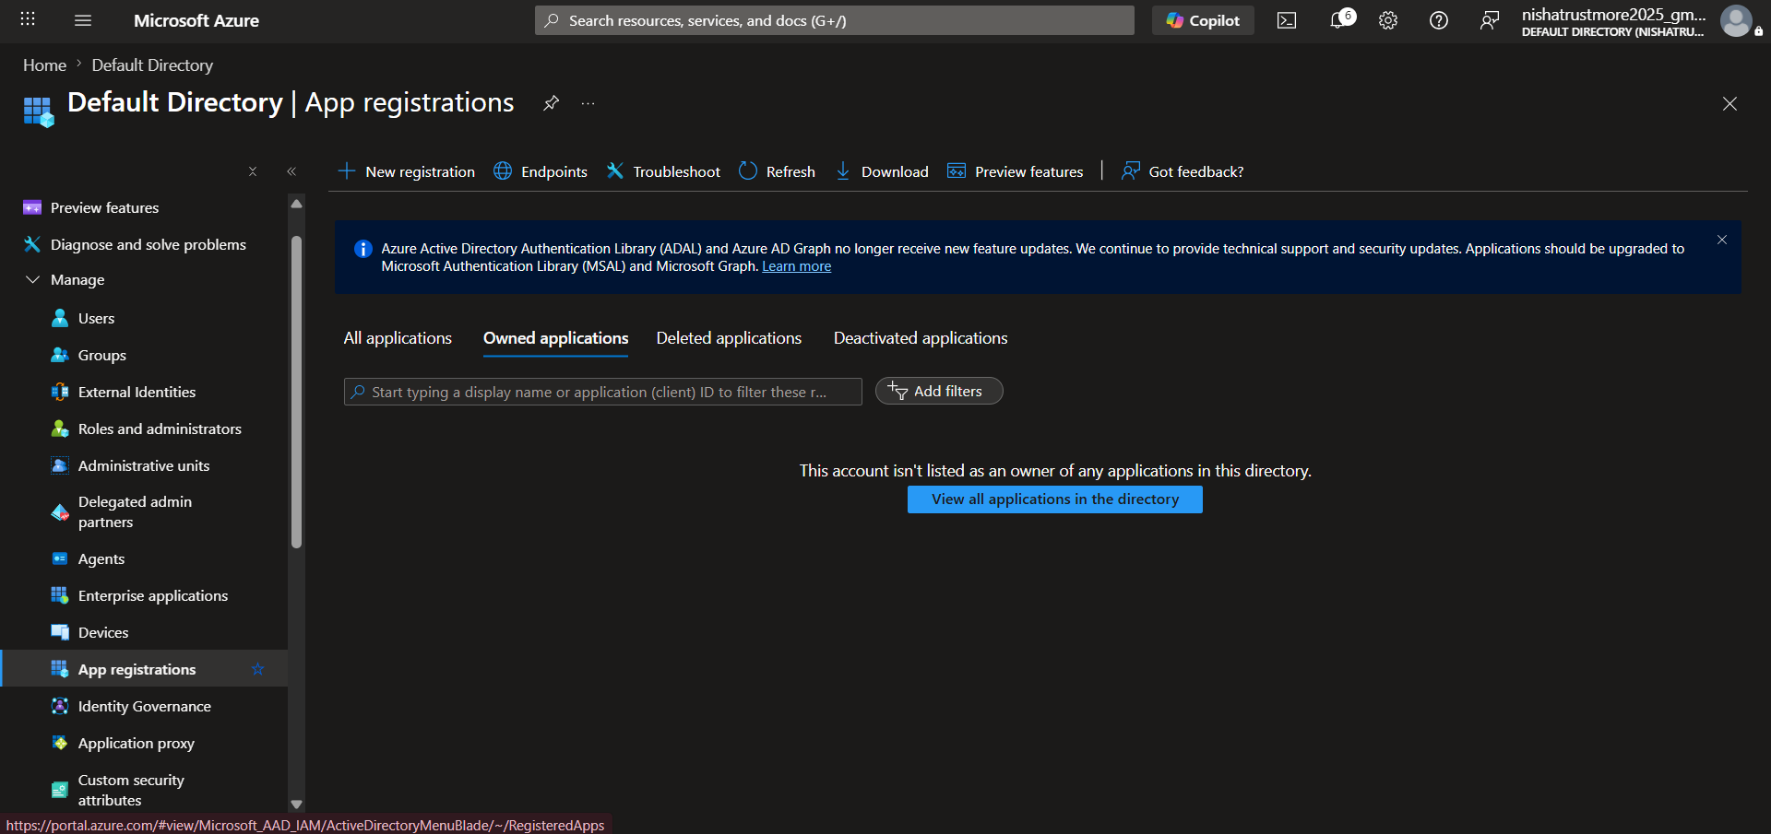

- Entered the name Customer-review for the app registration and clicked Register.
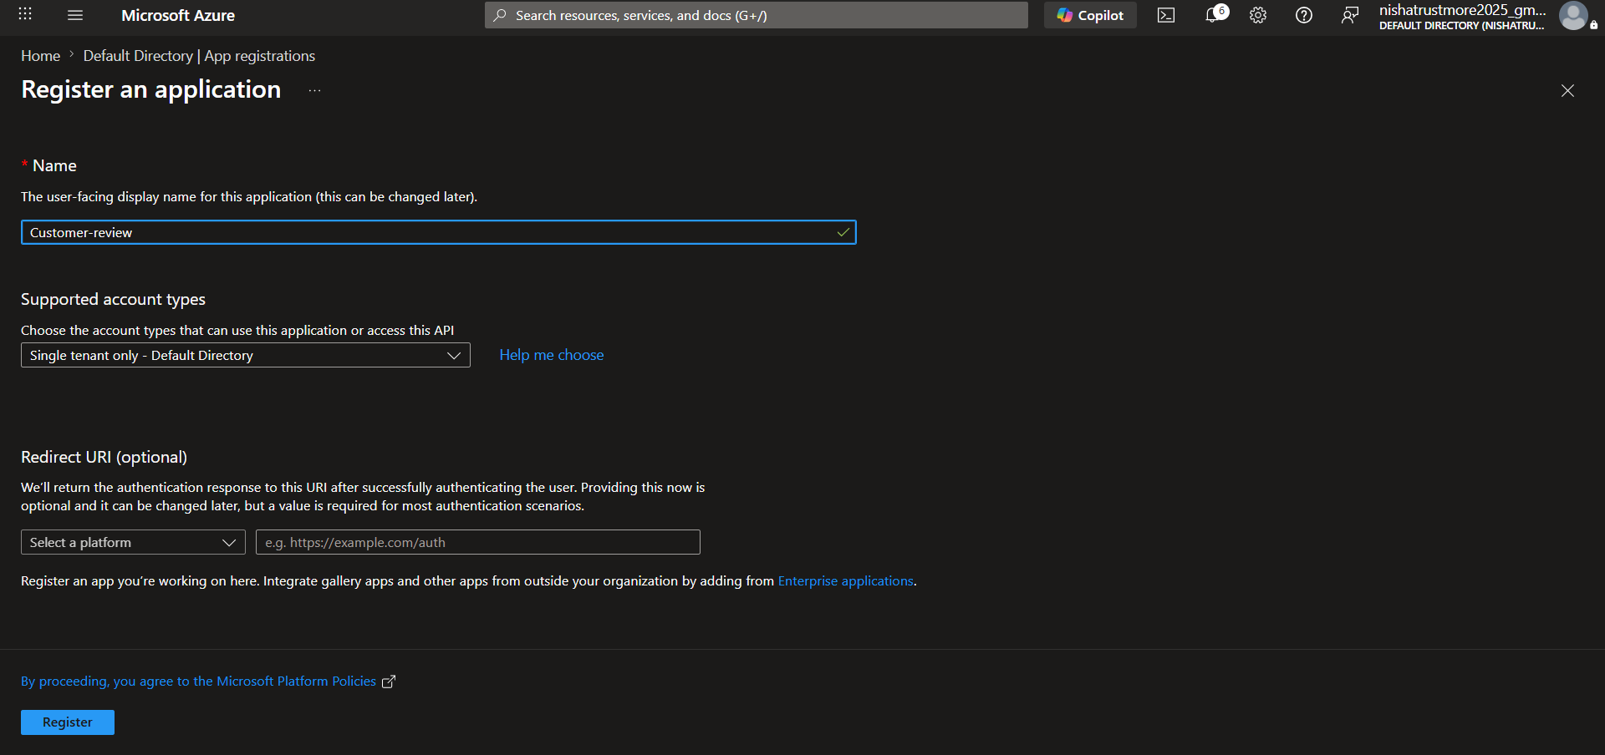

- After creating the app registration, copied the Application (Client) ID and Directory (Tenant) ID.
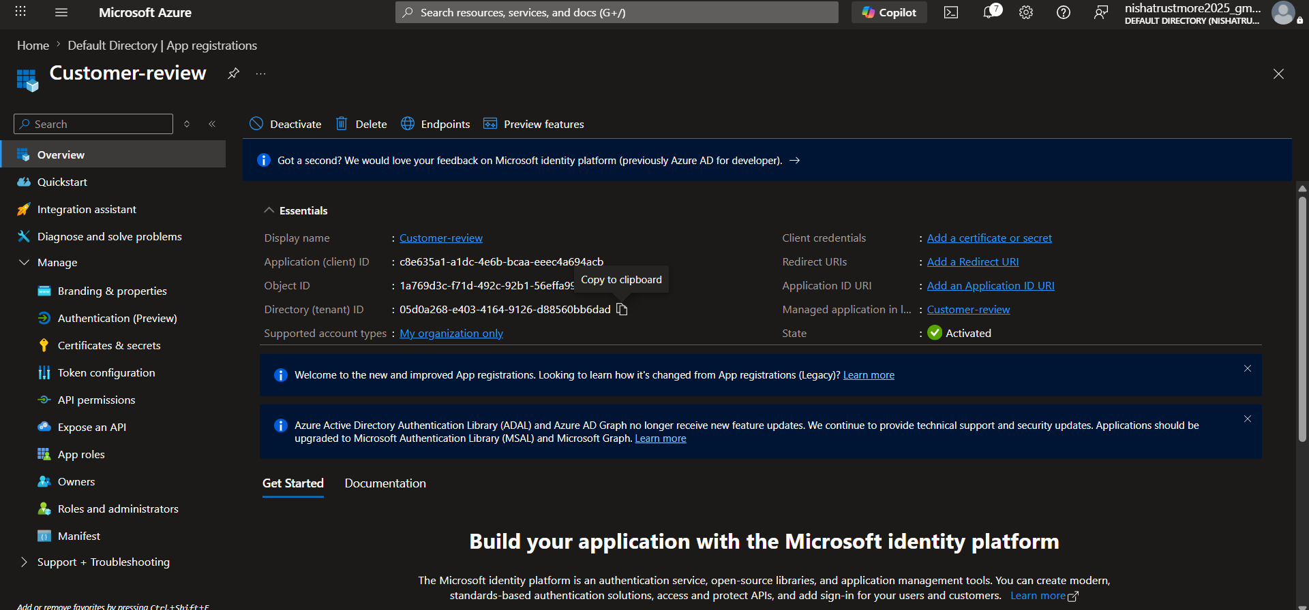

- In the Manage tab, navigated to Certificates & Secrets and created a New Client Secret.
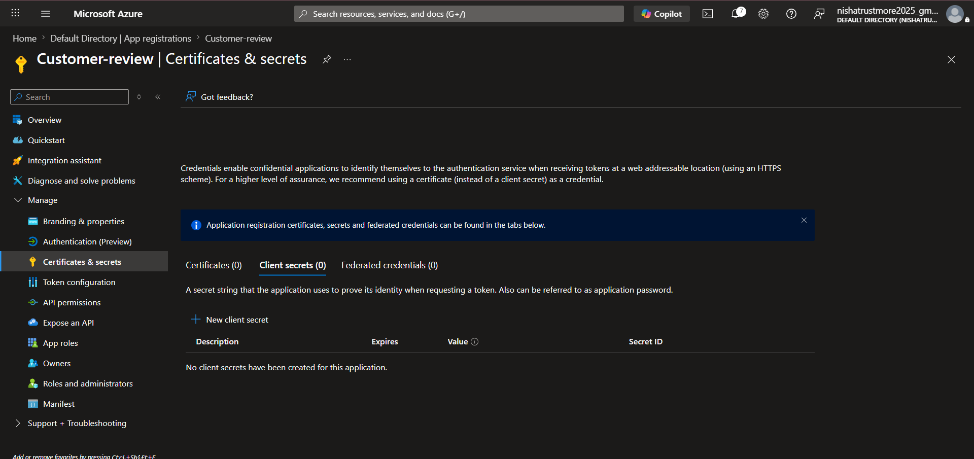

- Copied and securely saved the Client Secret Value after it was created.
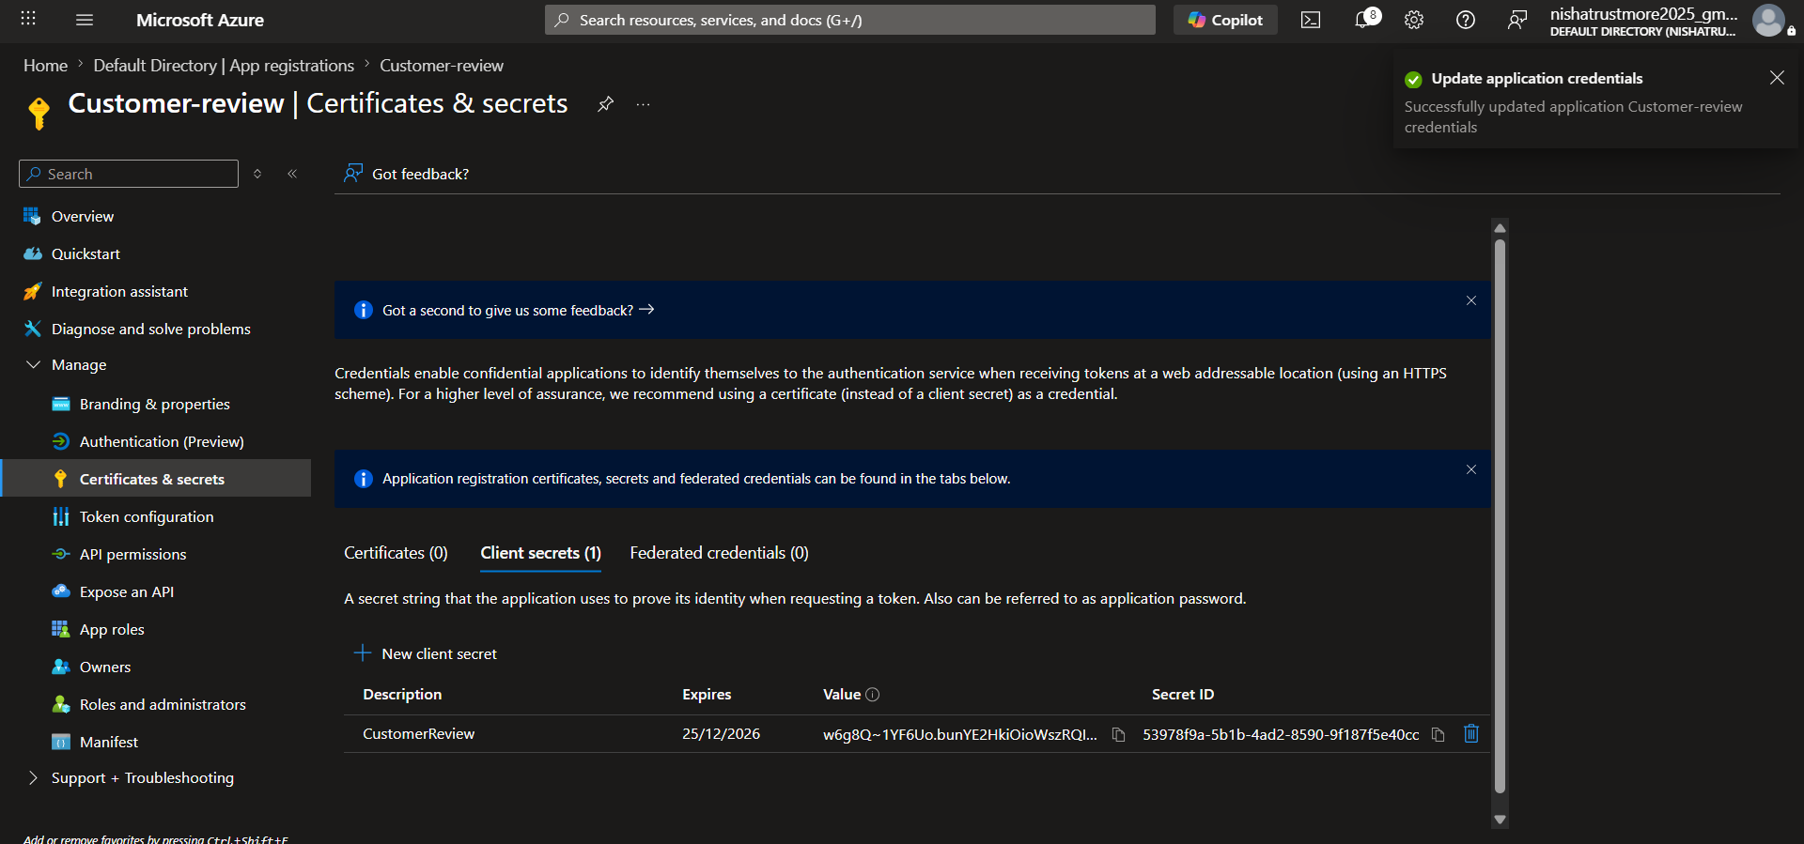

- Open Access Control (IAM) – Opened the stamazonreviewdldev storage account and navigated to Access Control (IAM).
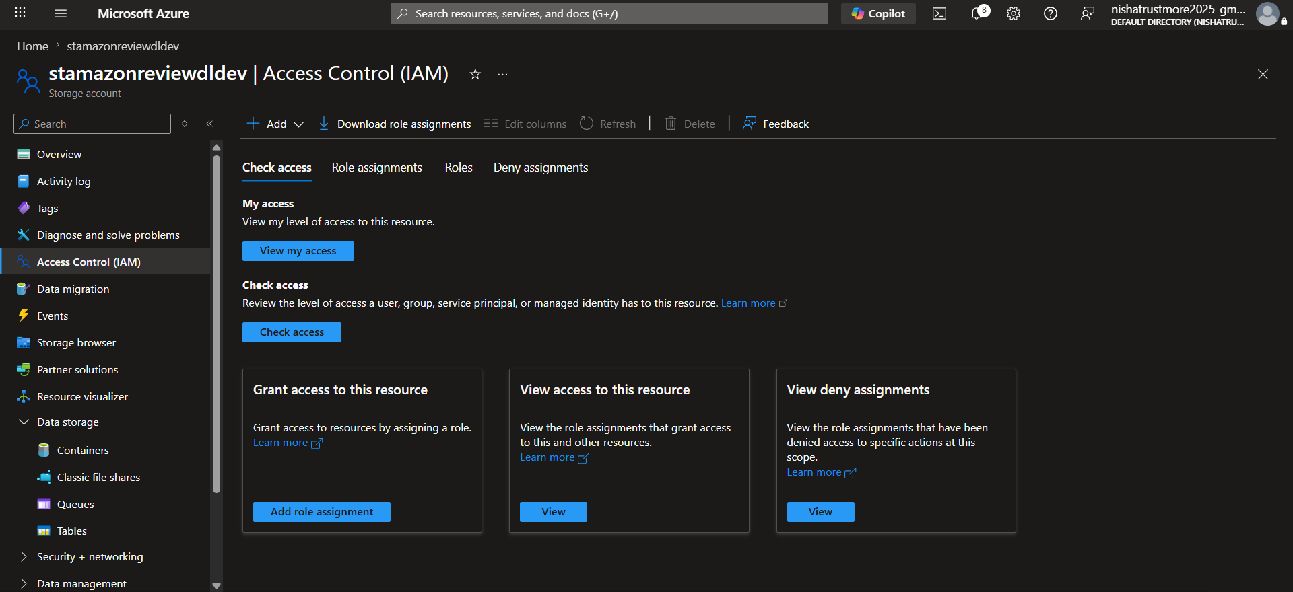

- Assign Storage Blob Data Contributor Role – Clicked Add Role Assignment, selected Storage Blob Data Contributor, and clicked Next.
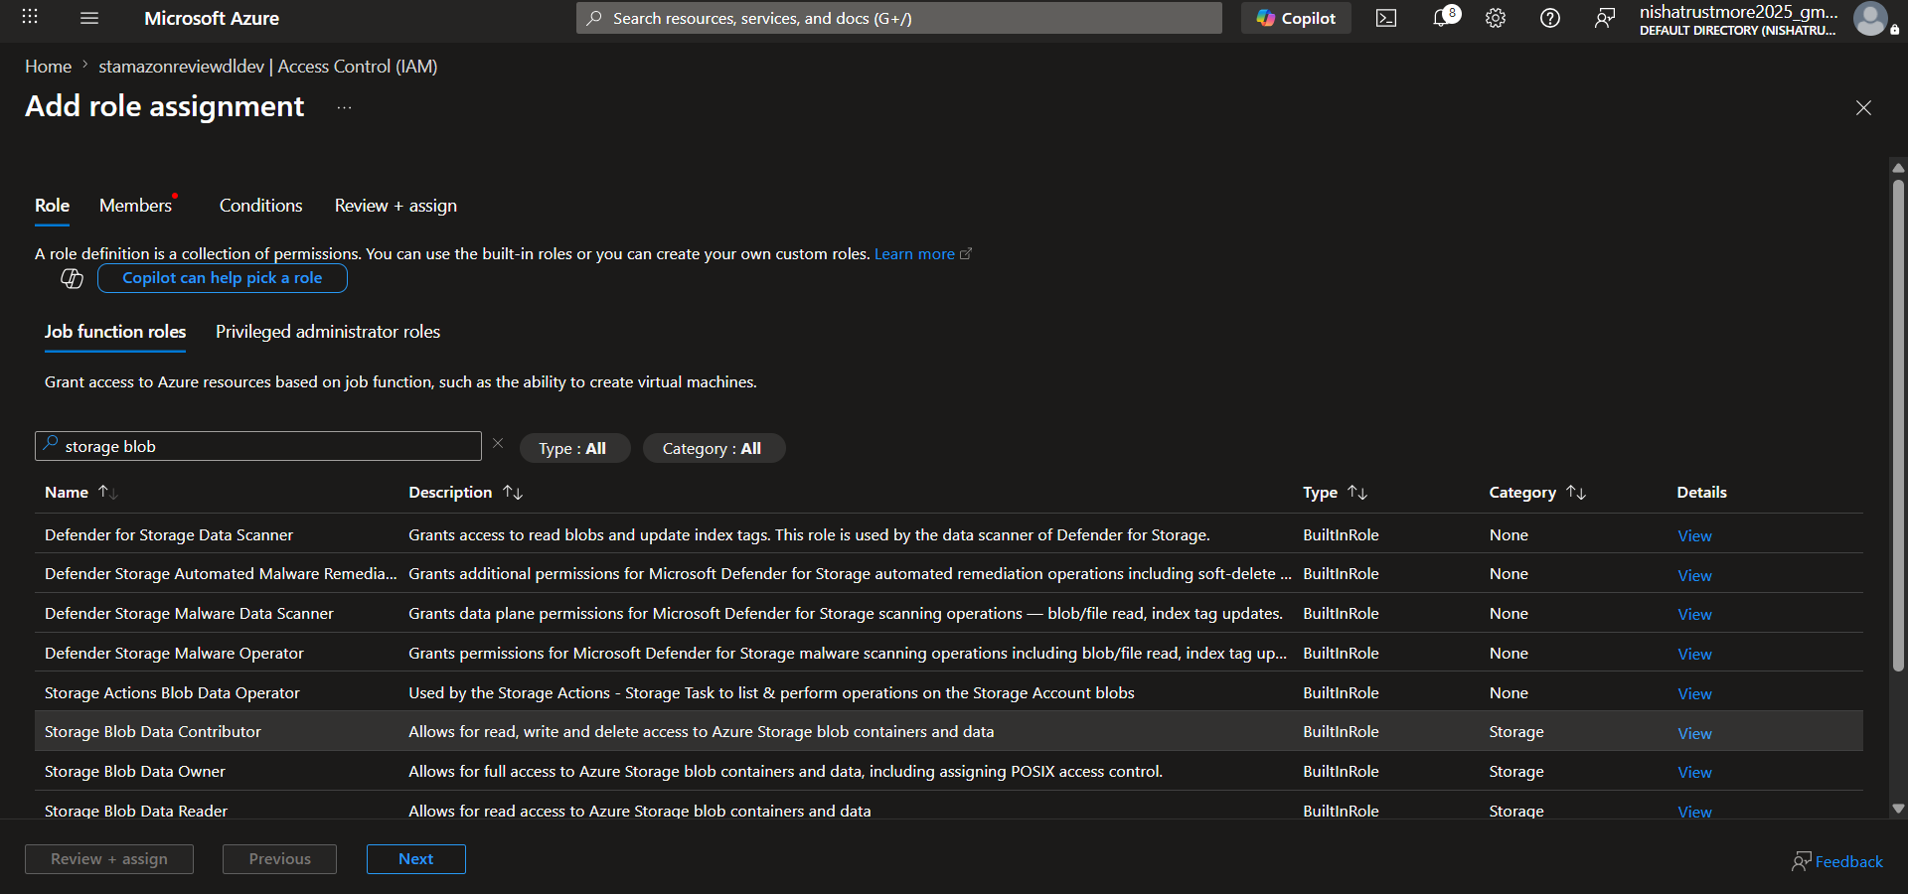

- Assign Role to App Registration – Selected Customer-review as the member and clicked Review + Assign to grant the required permissions.
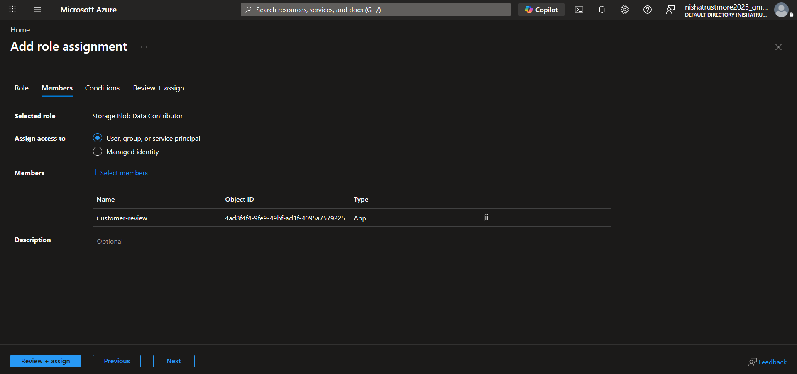

Step4:- Create Databricks Notebook and Access Data

- Create Project Folder – In Workspace, created a new folder named CustomerReviewsProject and Create.
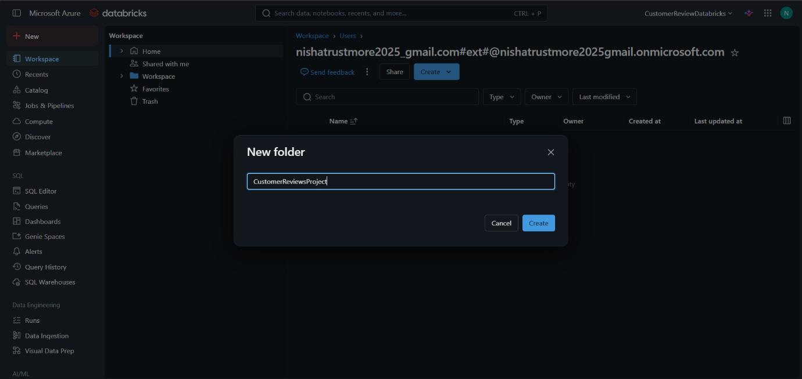

- Created a new notebook and renamed it to silver_layer.
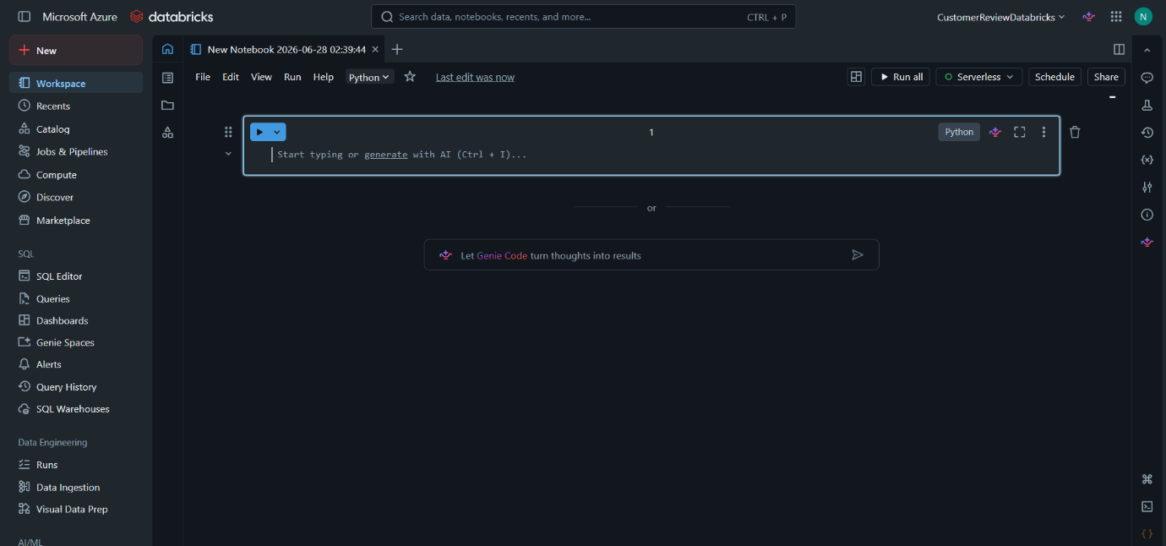

- Opened the Azure Databricks storage access documentation, navigated to Azure Service Principal, and copied the required commands to configure access to Azure Data Lake Storage Gen2.
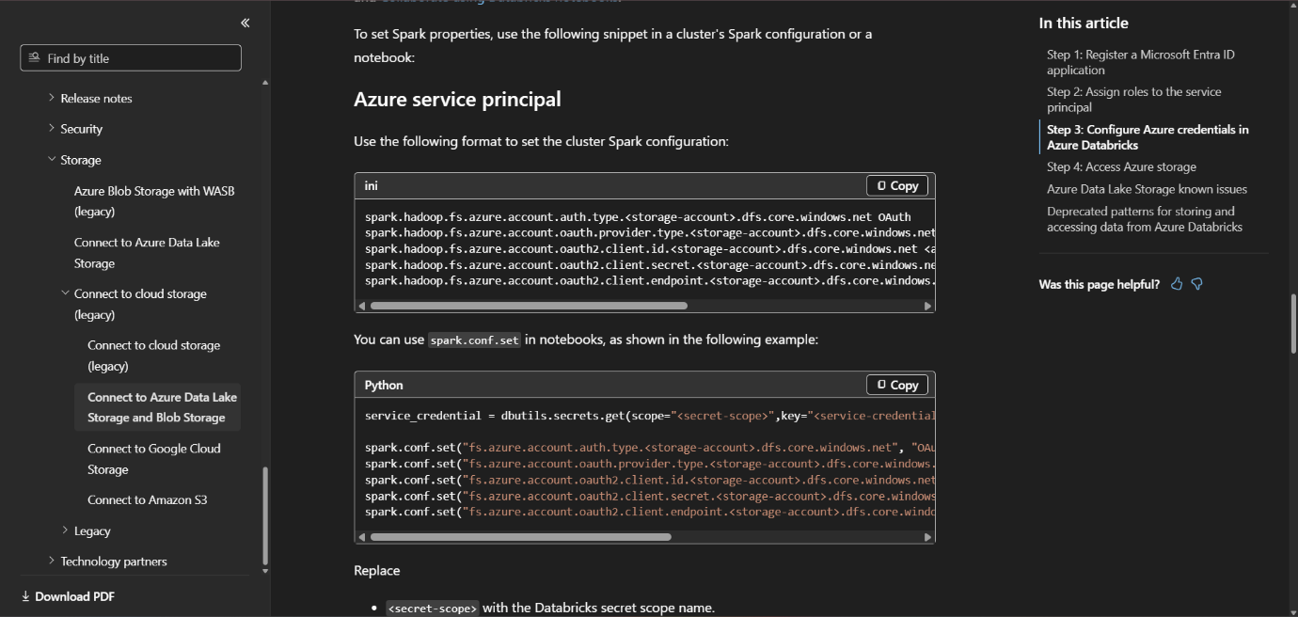

- Update Configuration Values – Replaced the placeholders in the copied commands with the Storage Account Name, Application (Client) ID, Directory (Tenant) ID, and Client Secret Value.
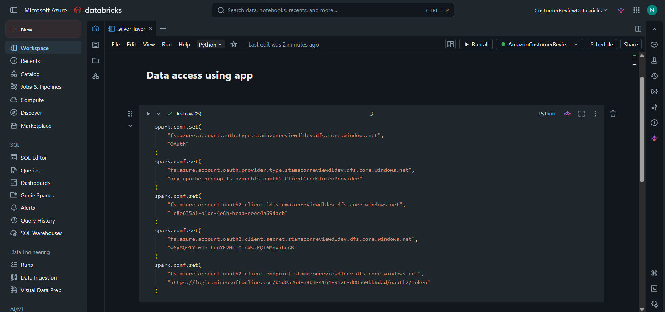

- Tested the connection to the Azure Data Lake Storage Gen2 account.
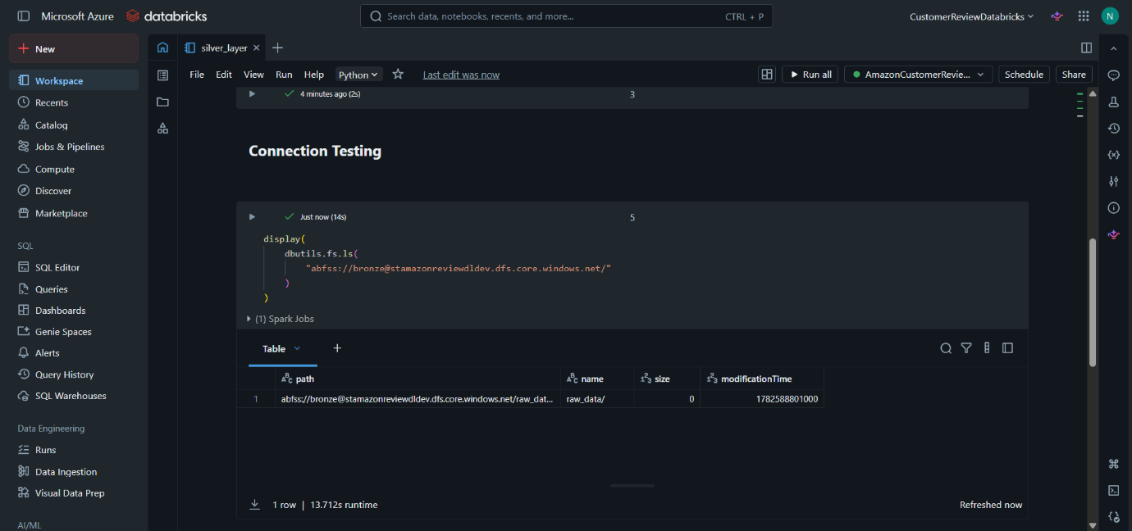

Step 5:- Perform Data Transformation.
- Loaded the data from the Azure Data Lake Storage Gen2 account into the Databricks notebook.
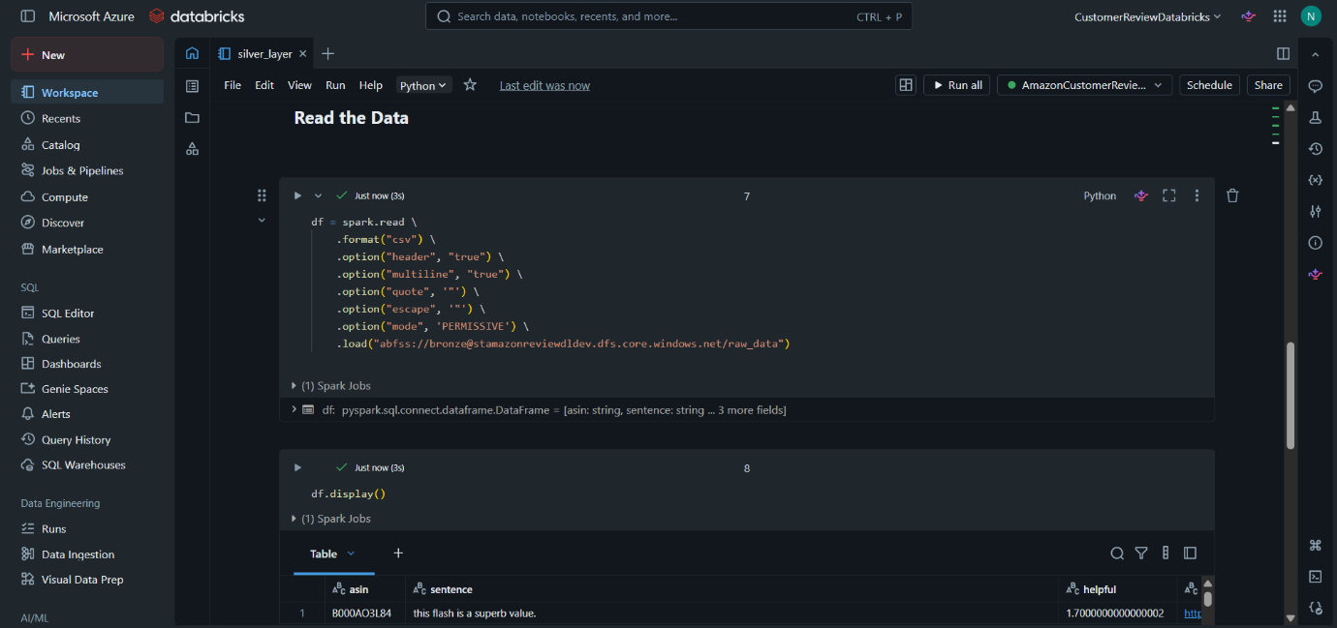

- Renamed the columns and converted the required columns to the appropriate data types.
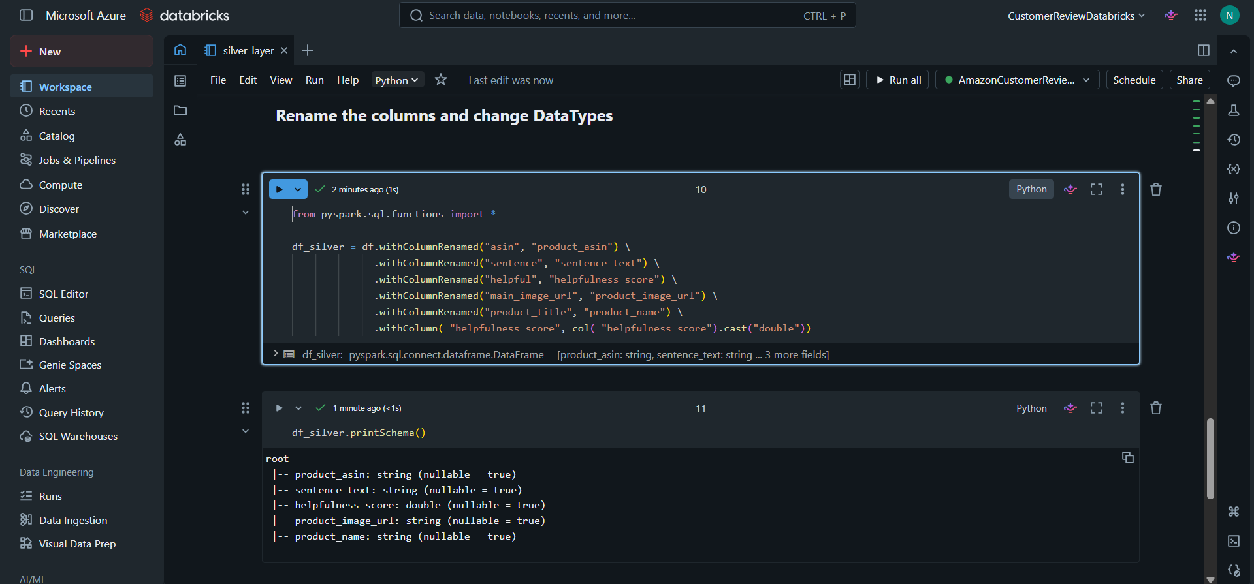

- Counted the null values present in each column.
- Removed whitespaces from text fields.
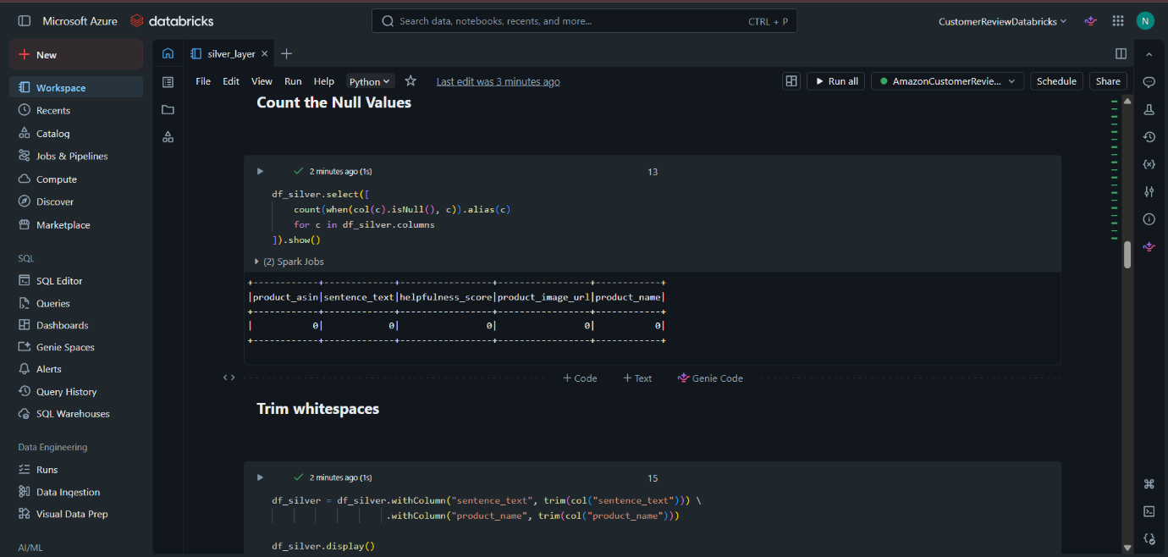

- Calculated the character length of each review.
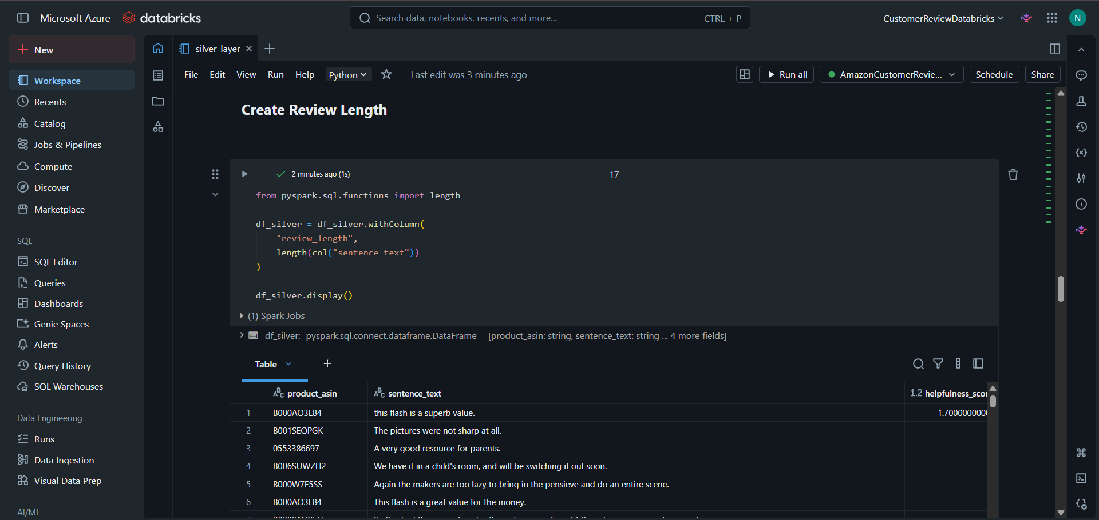

- Word Count Calculation – Computed the total number of words in each review.
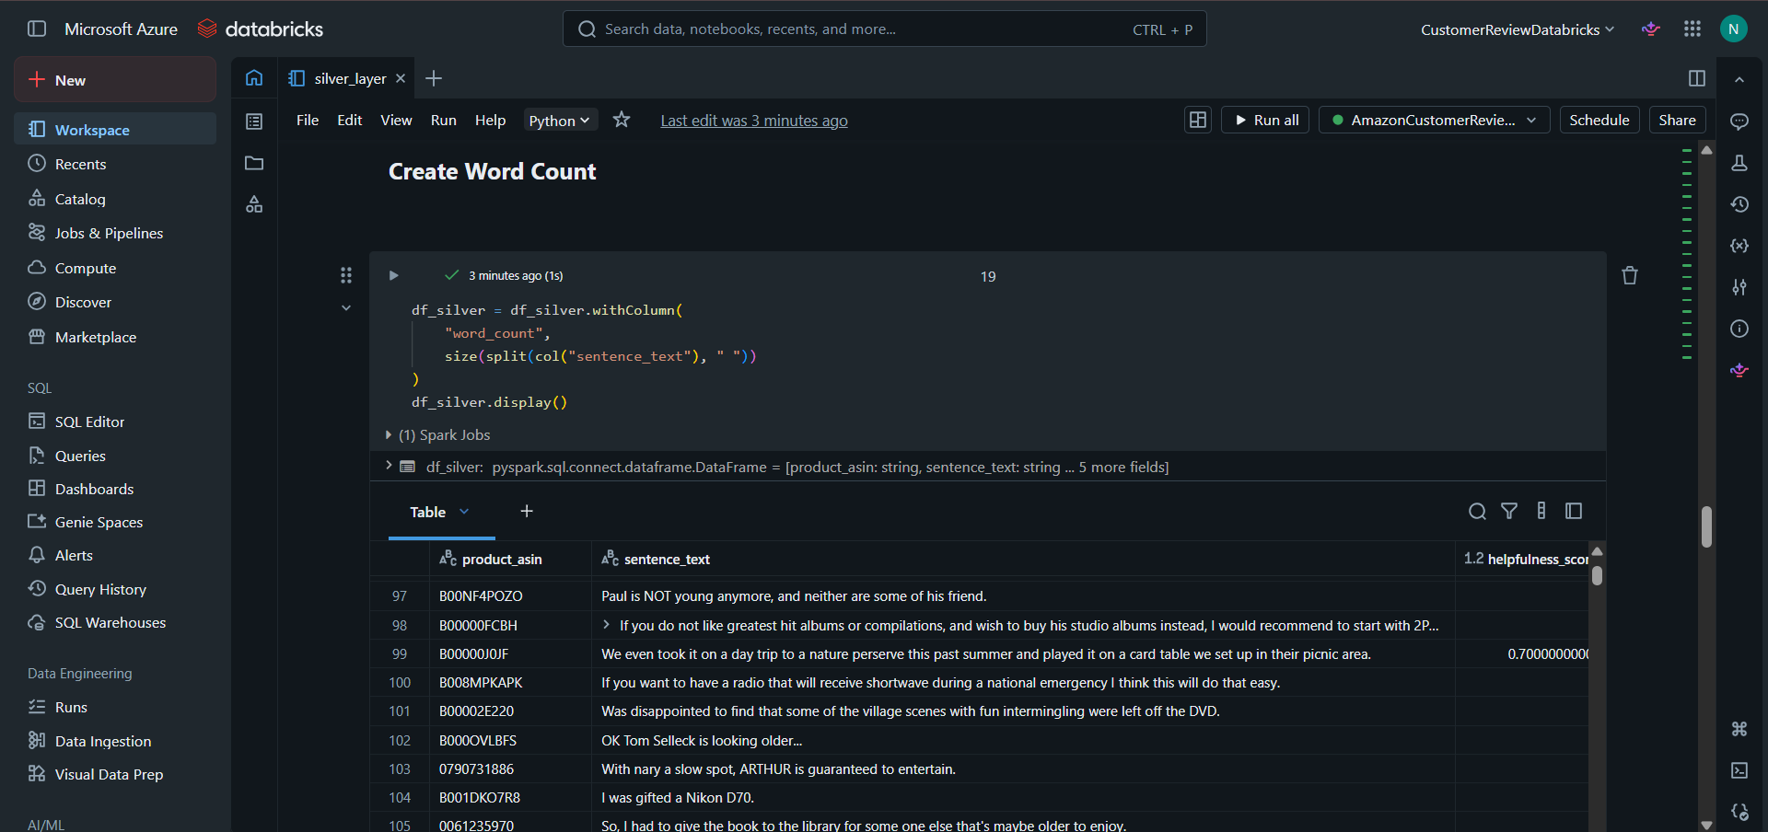

. Helpfulness Categorization – Categorized reviews into Low, Medium, and High based on their helpfulness score using predefined thresholds.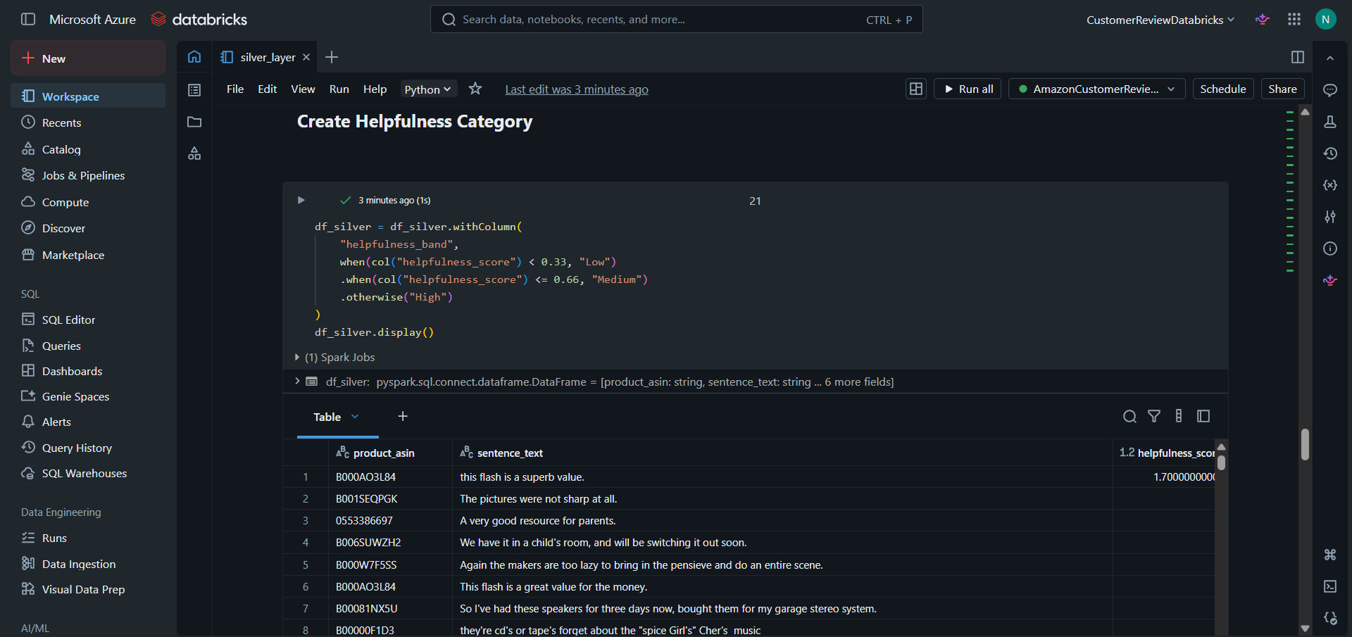

- Review Filtering – Removed reviews with fewer than six words.
- Added an ingestion_source column to identify the origin of each record as Batch.
- Added an ingestion_timestamp column to record when each record was processed into the pipeline.
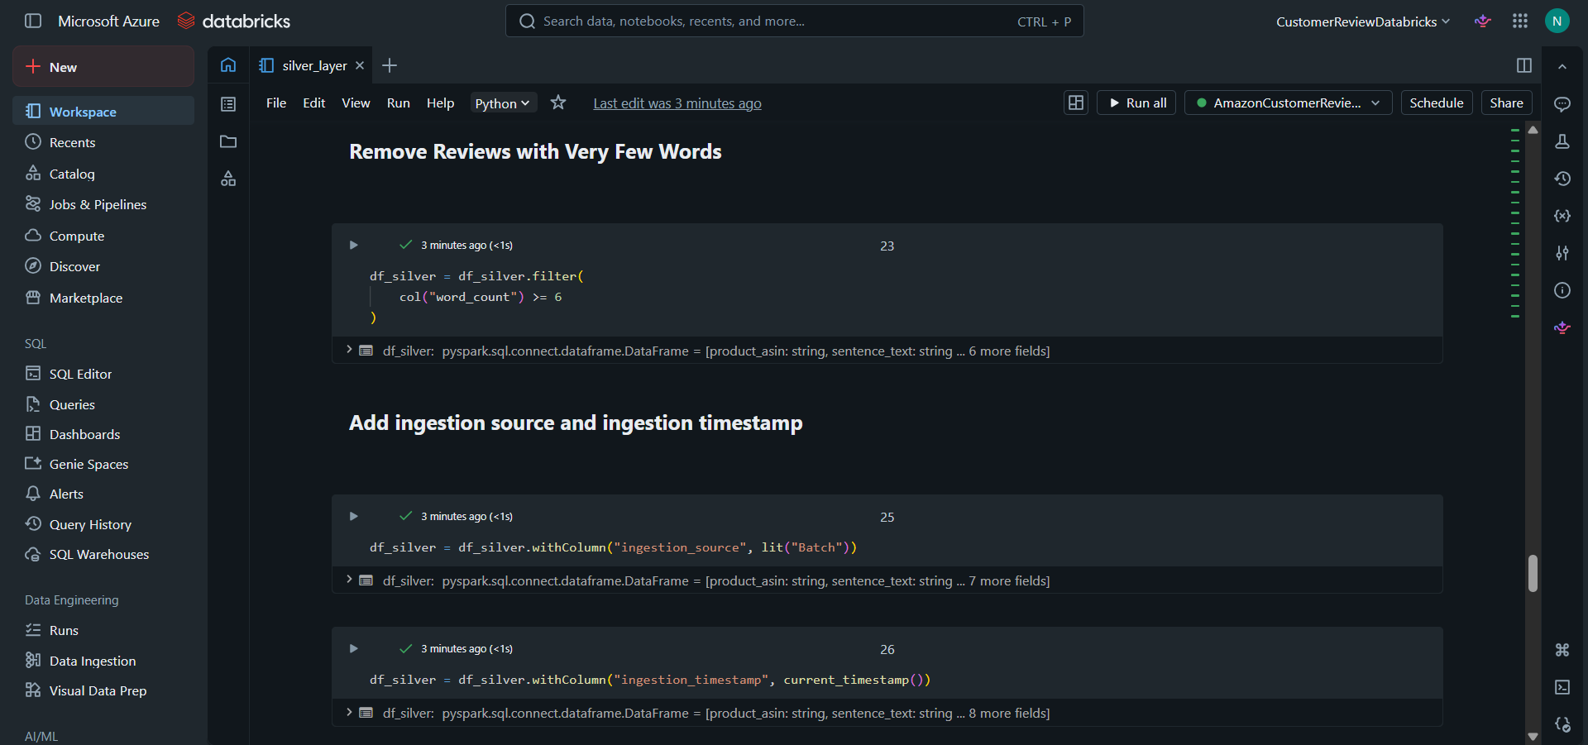

- Created indicator columns (is_very_short, is_very_long, and has_low_detail) to identify review characteristics associated with review quality.
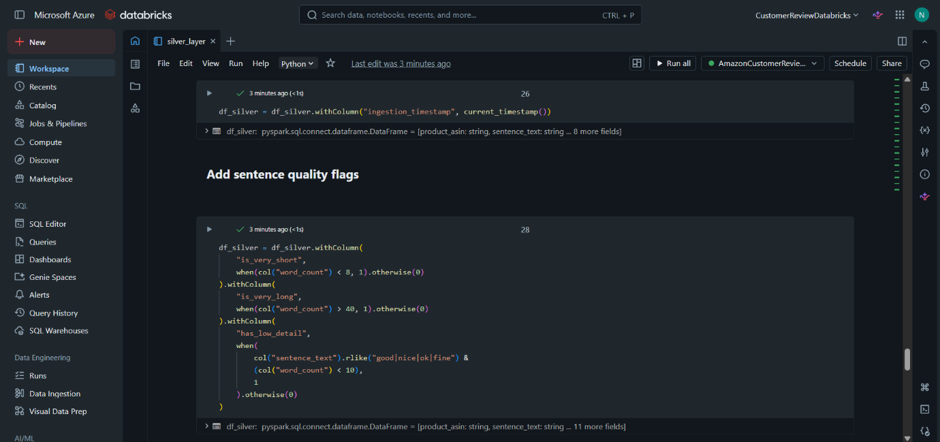

- Removed duplicate review sentences using a hash-based window function to retain only the first occurrence of each unique review.
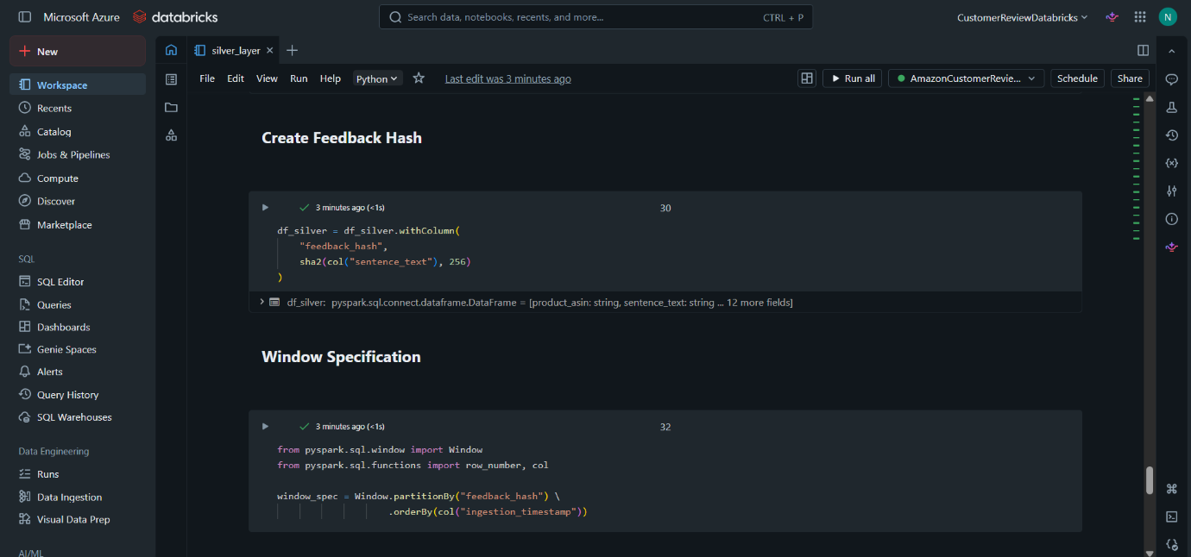

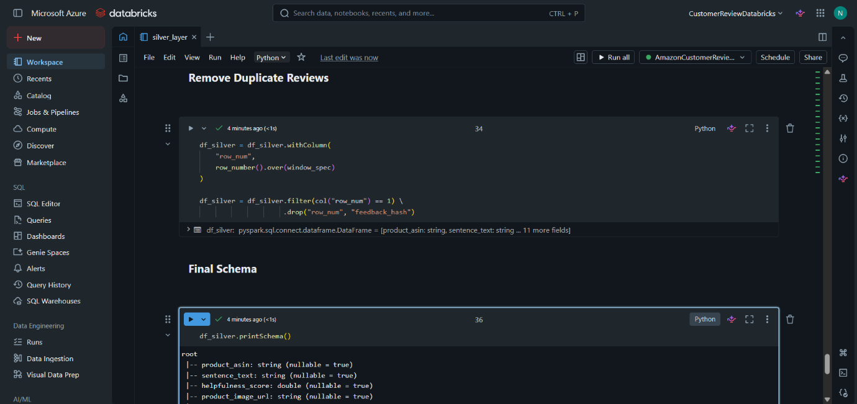

- Stored the transformed Silver dataset in Delta format.
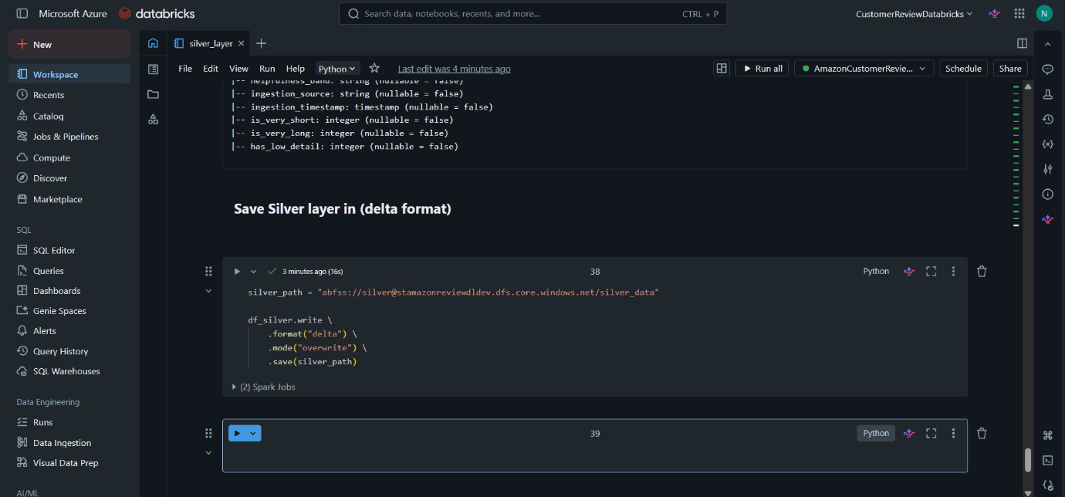

- Transformation data has saved to the silver_data container.
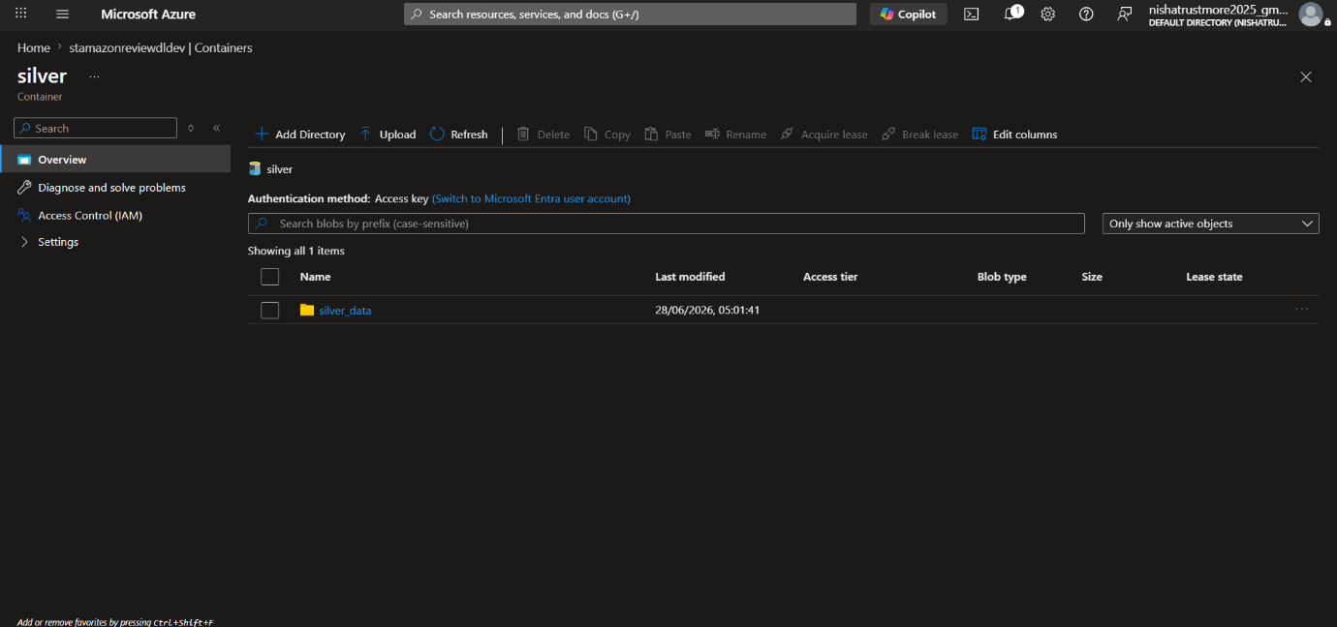

Phase-3 (gold layer):

Step1 :- Creating Azure Synapse Analytics:
- Create an Azure Synapse Analytics workspace “customer-service-synapse”.
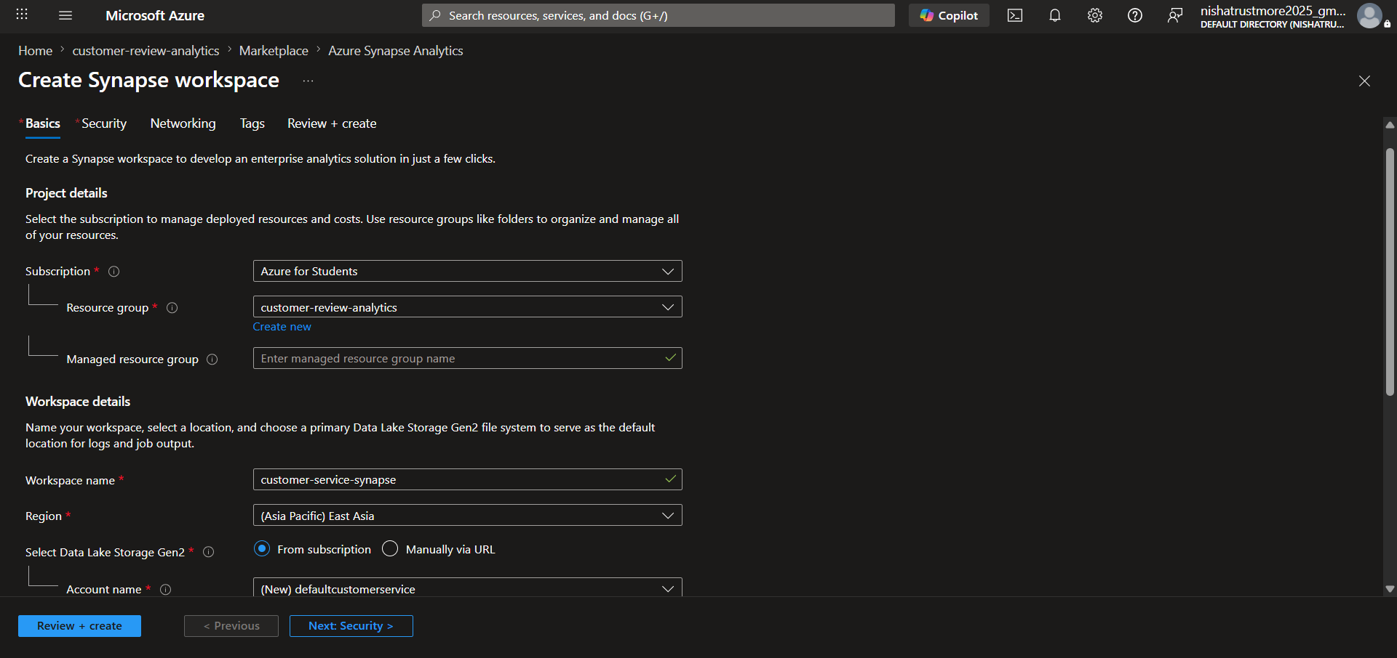

- Set the SQL Server administrator login credentials, including the username and password.
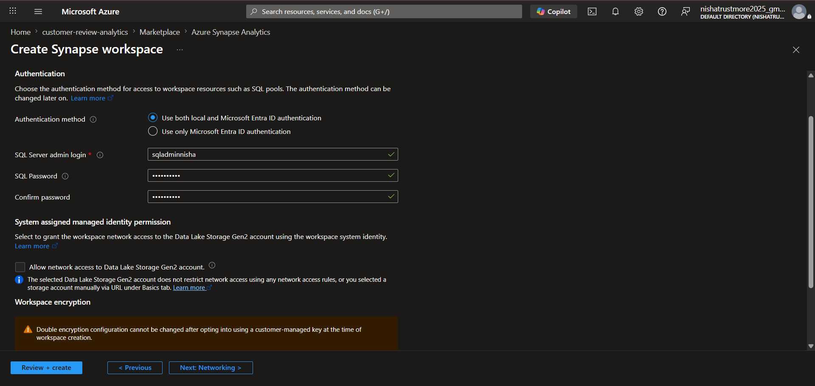

- Click Create to deploy the Azure Synapse Analytics workspace.
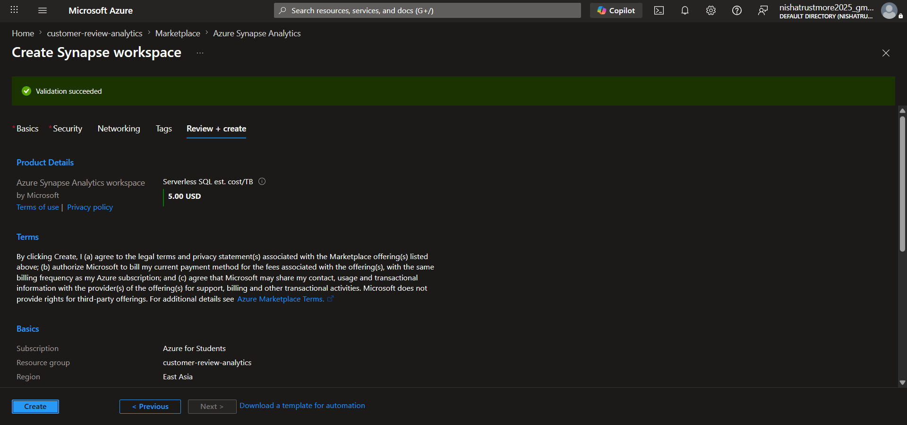

- The Azure Synapse Analytics workspace was successfully created.
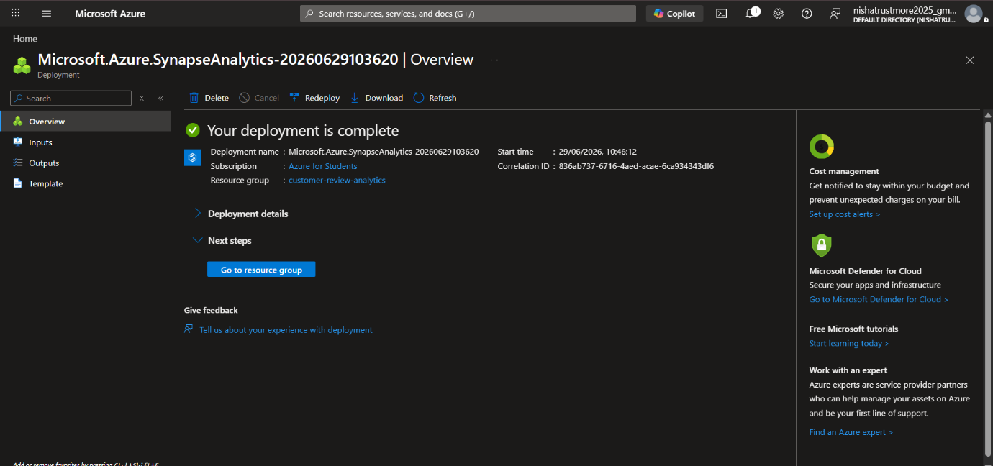

Step 2: Provide Data Lake Storage access to the Azure Synapse Analytics workspace.
- Go to the “stamazonreviewdldev” Storage Account, navigate to Access Control (IAM), and click Add role assignment.
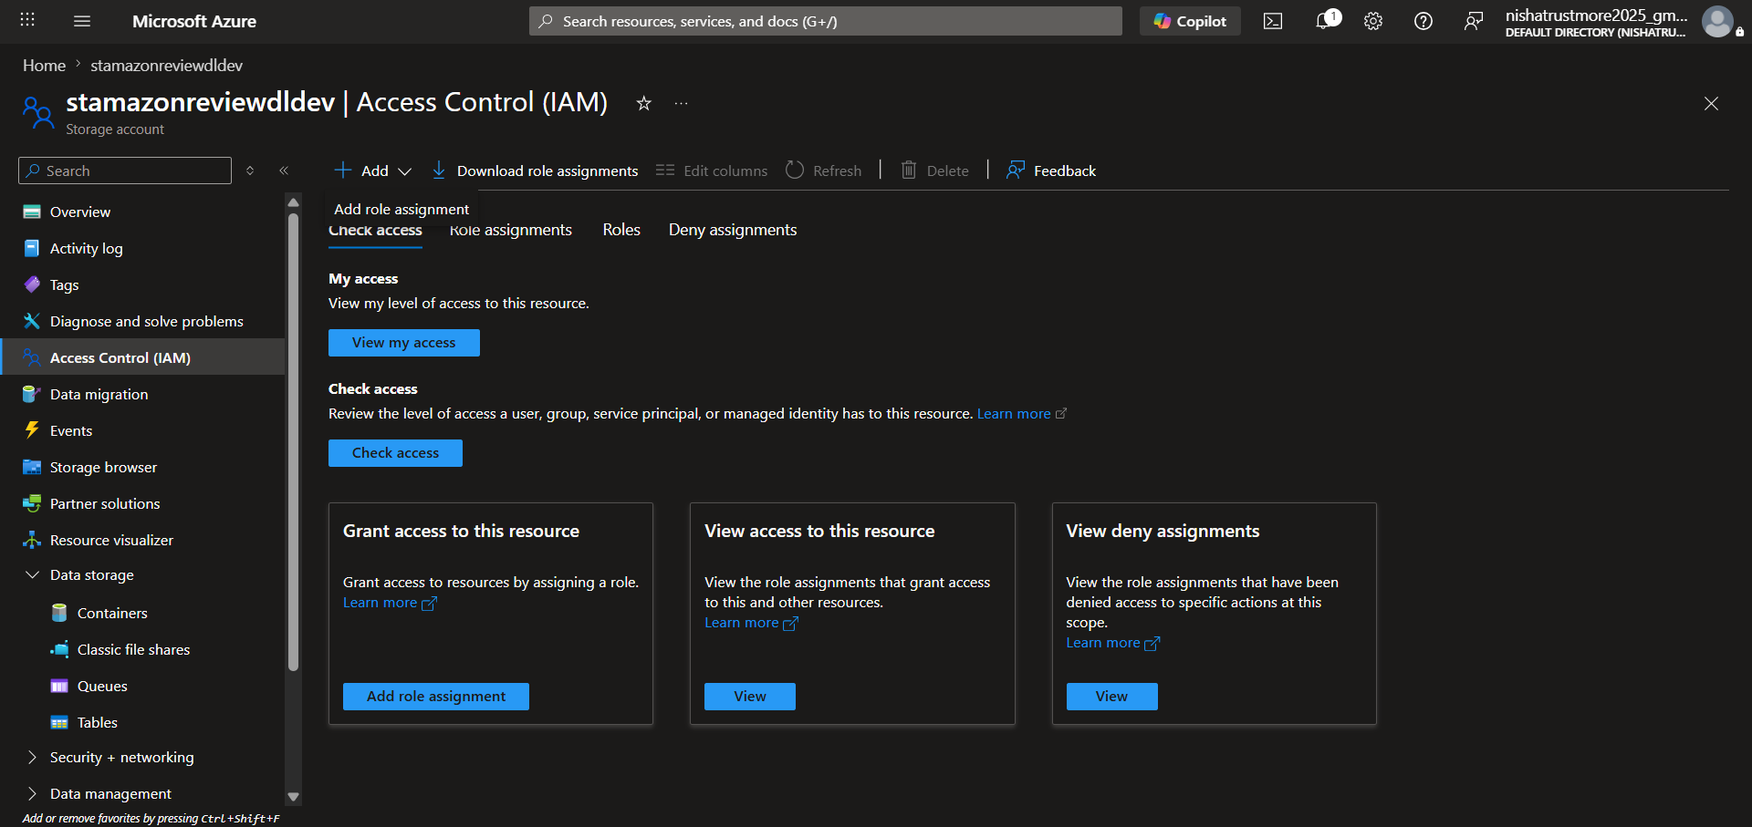

- Search for and select Storage Blob Data Contributor, then click Next.
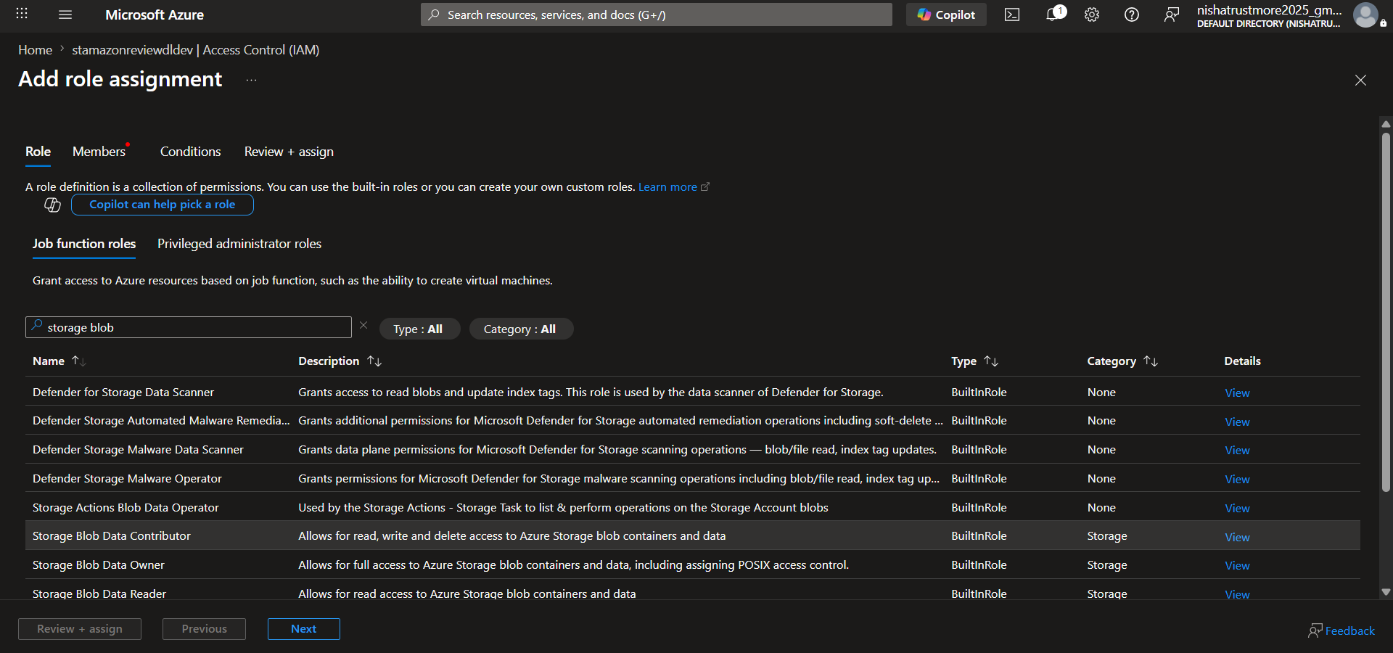

- Select Managed Identity, click Select members, choose “customer-service-synapse”, and then confirm the selection.
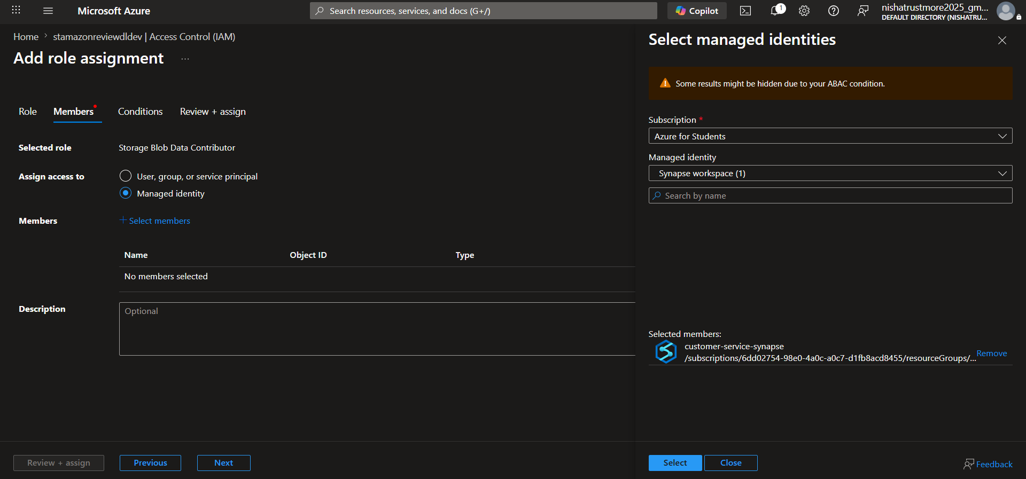

- Click on Review+ assign and the role is successfully assigned to the Azure Synapse Analytics workspace.
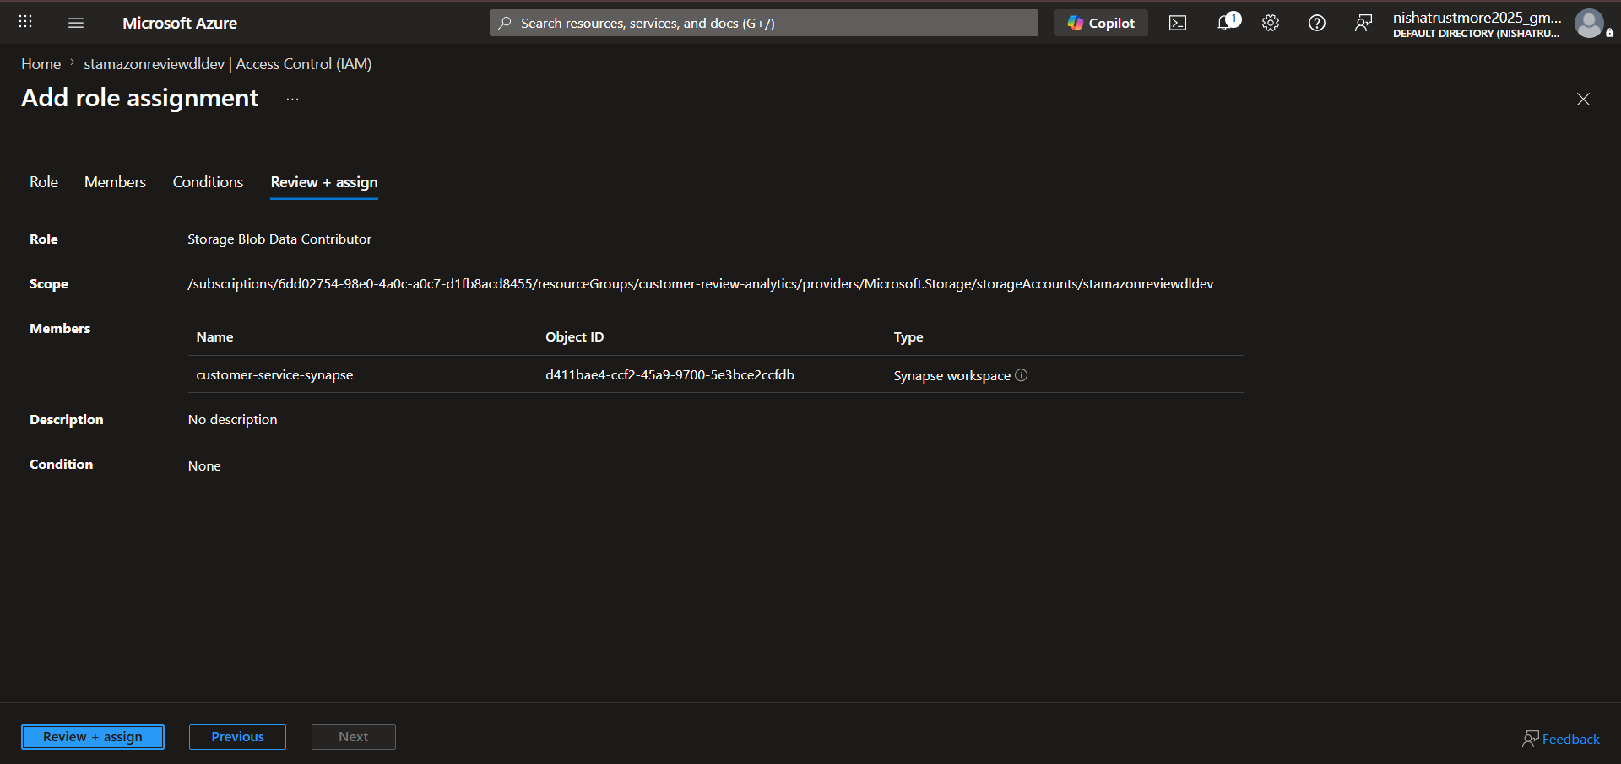

Step 3: Create a database in Azure Synapse Analytics.
- Go to the Data tab and click + Create, then select SQL Database.

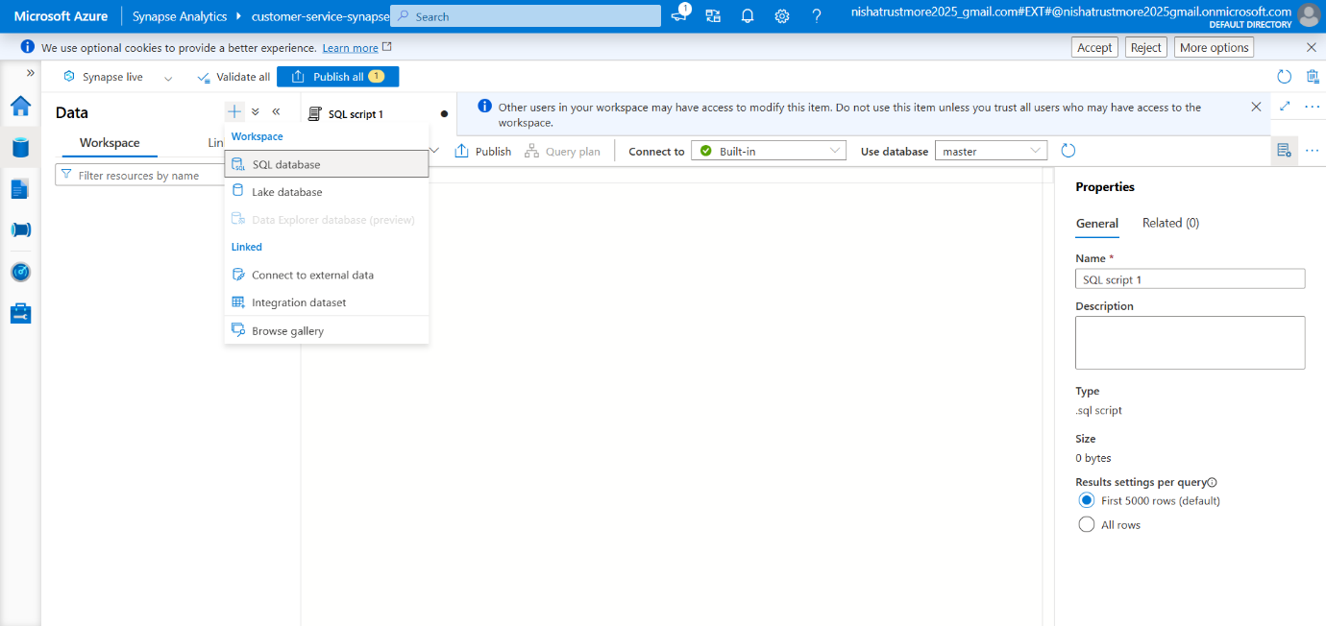

- Select Serverless, enter the database name, and click Create.
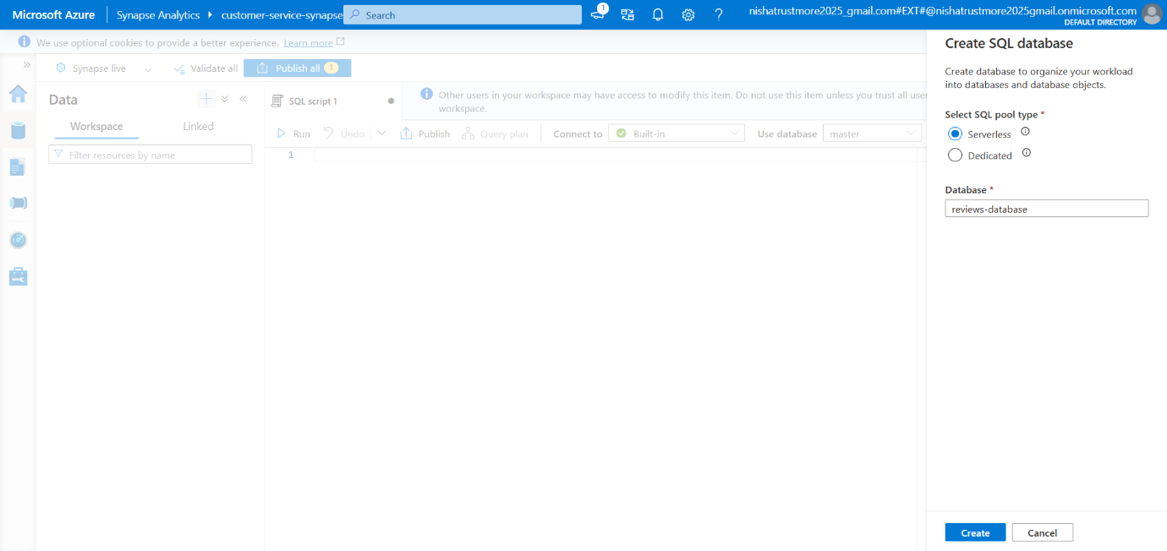

- Go to the “stamazonreviewdldev” Storage Account, navigate to Access Control (IAM), and click Add role assignment.
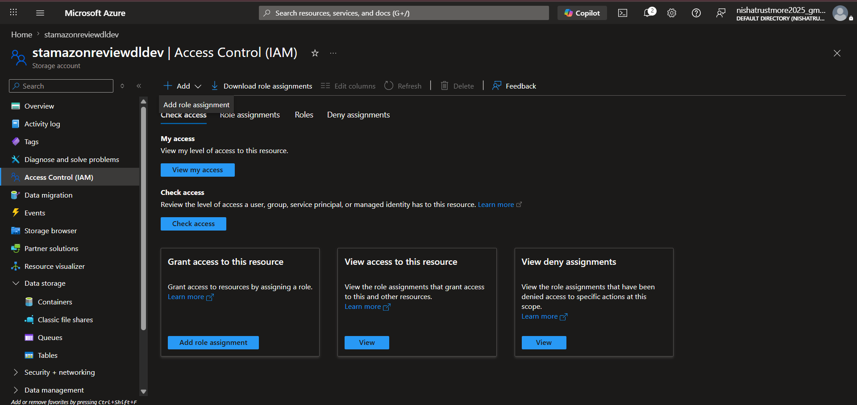

- Search for and select Storage Blob Data Contributor, then click Next.
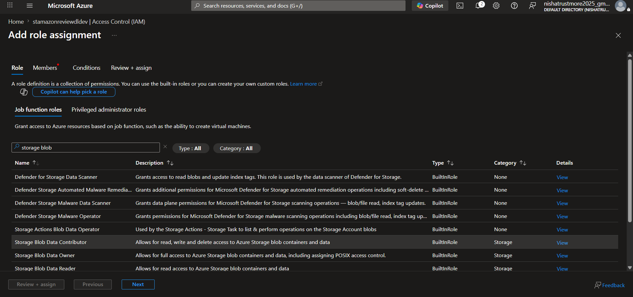

- Select User, group, or service principal, choose the required User ID, and click Review + assign.
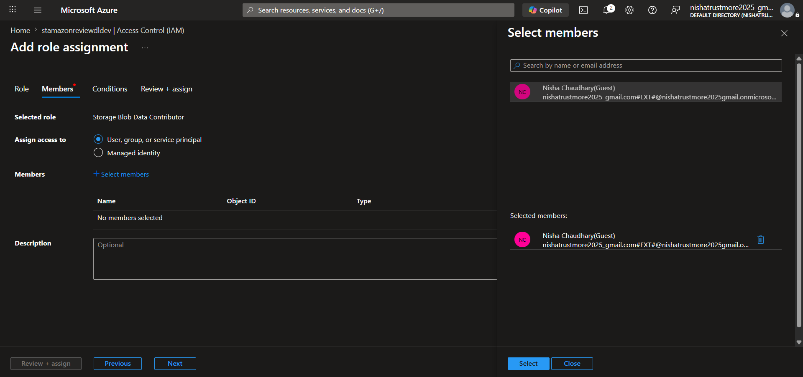

- Click Review + assign to complete the role assignment. The role is successfully assigned.
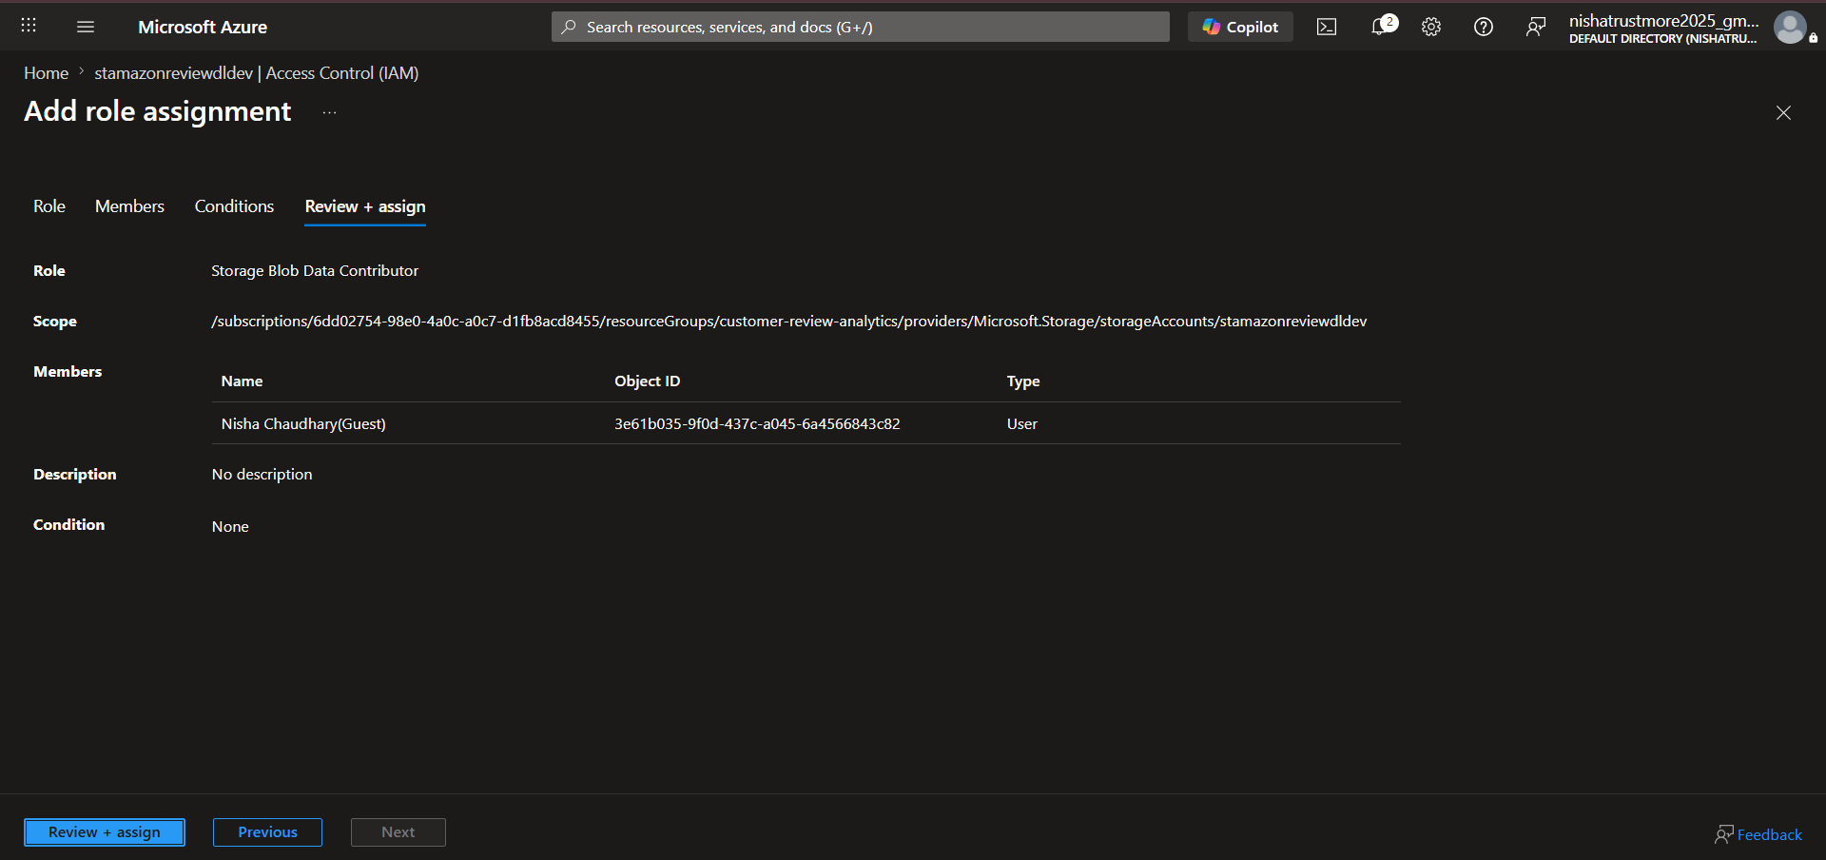

Step 4: Developing Business KPIs and Business Use Cases.
- Go to the Develop tab, click + and select SQL Script, then rename the script to ReadDataFromSilver.
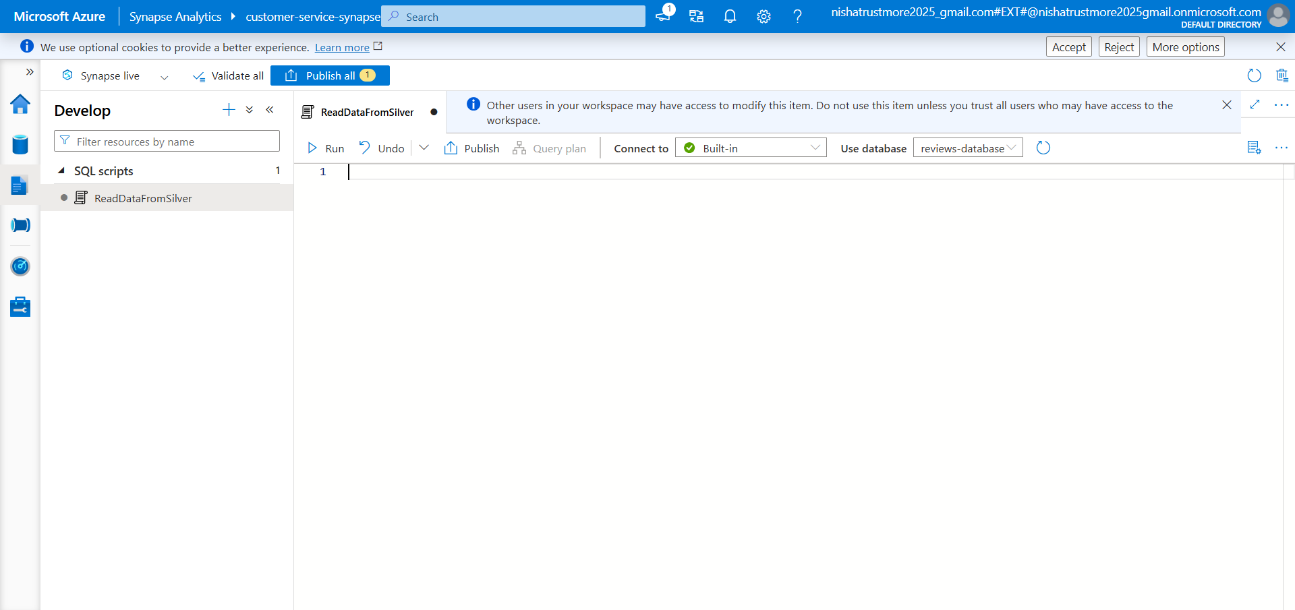

- Write the SQL script to read data from the Silver layer and create the required schema.
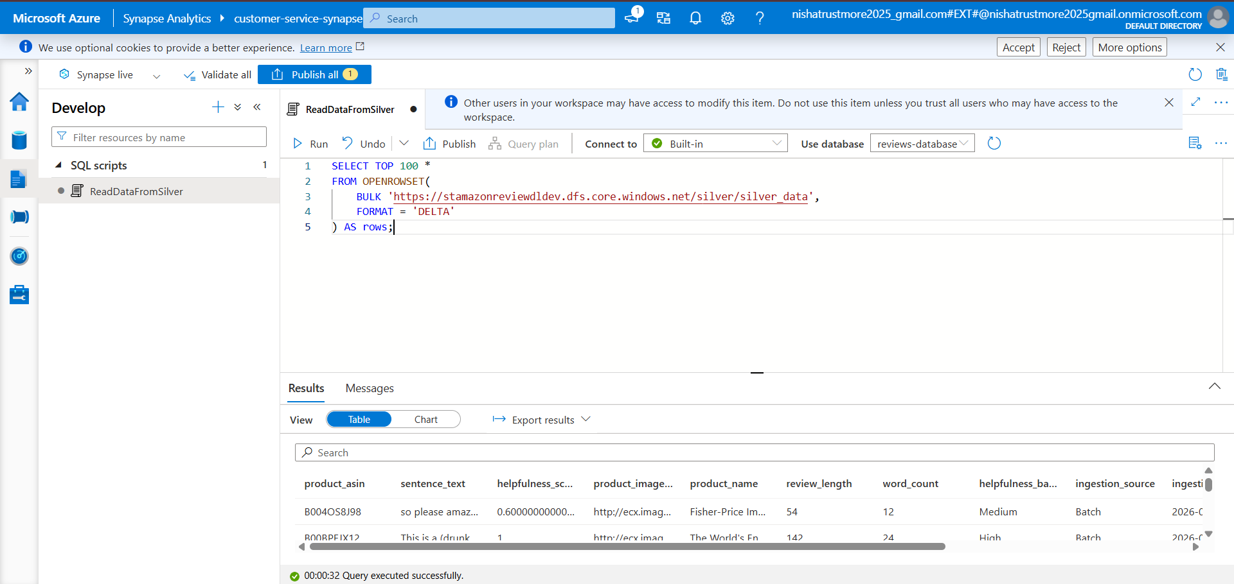

- Write the SQL script to create the required views in the Create Views Gold script.
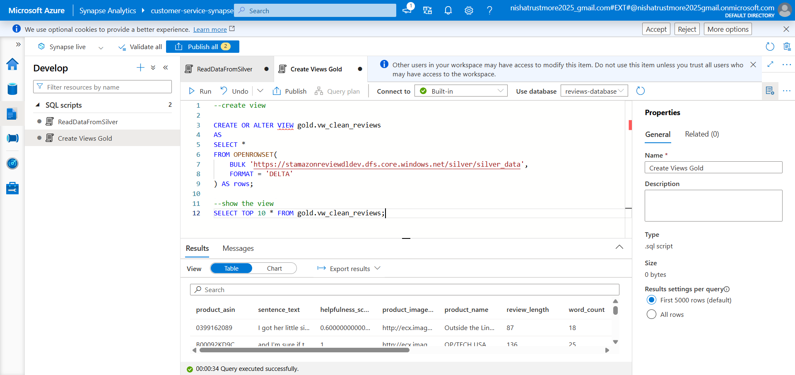

- Create a folder named GoldLayerPopulate. Inside the folder, create a SQL script named UseCase-1 and write the query for Use Case 1.
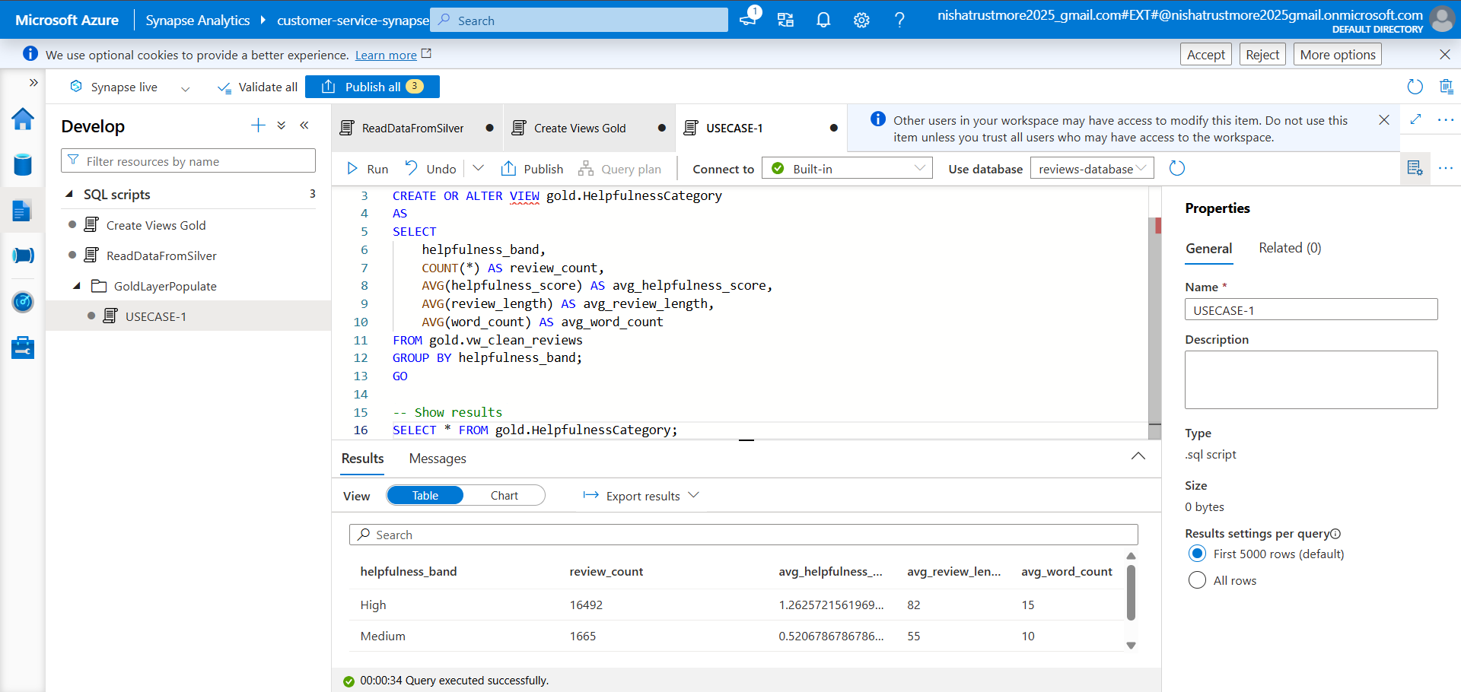

- Create a SQL script named UseCase-2 and write the SQL query for Use Case 2.
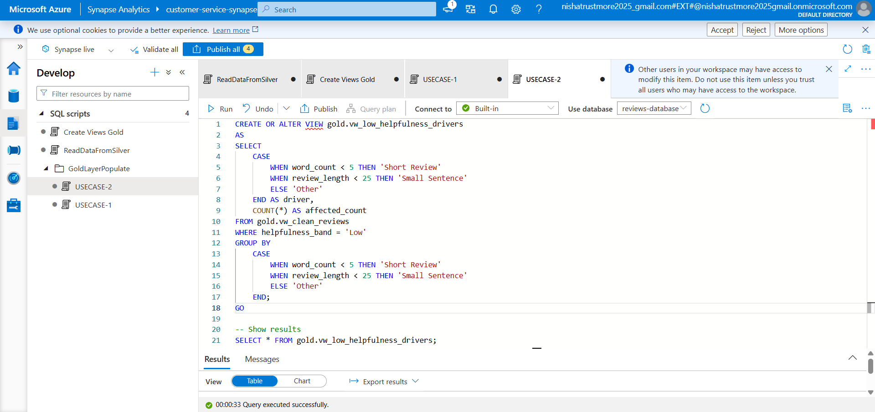

- Create a SQL script named UseCase-3 and write the SQL query for Use Case 3.
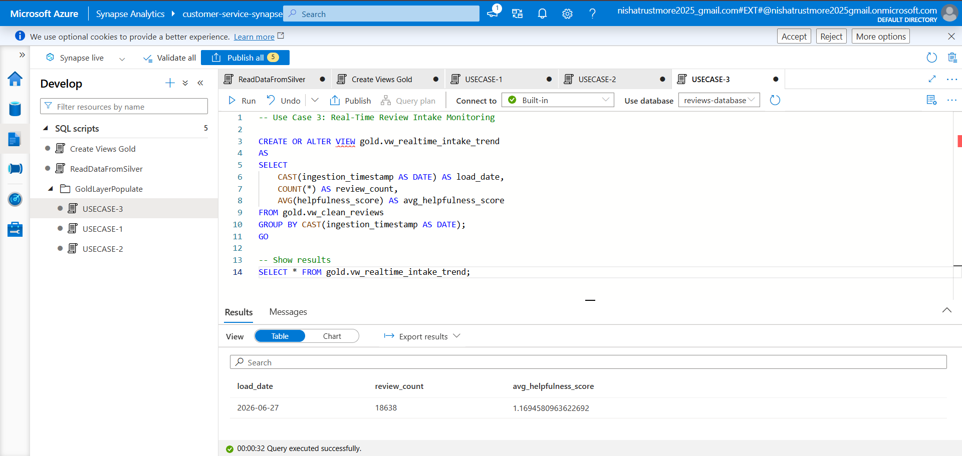

Step 5: Create External Tables and Store Data in the Data Lake.

- Create a folder named ExternalTables. Inside the folder, create a SQL script named CreateExternalTable, write the required SQL queries, create the Master Key, create the Database Scoped Credential, and configure the External Data Source.
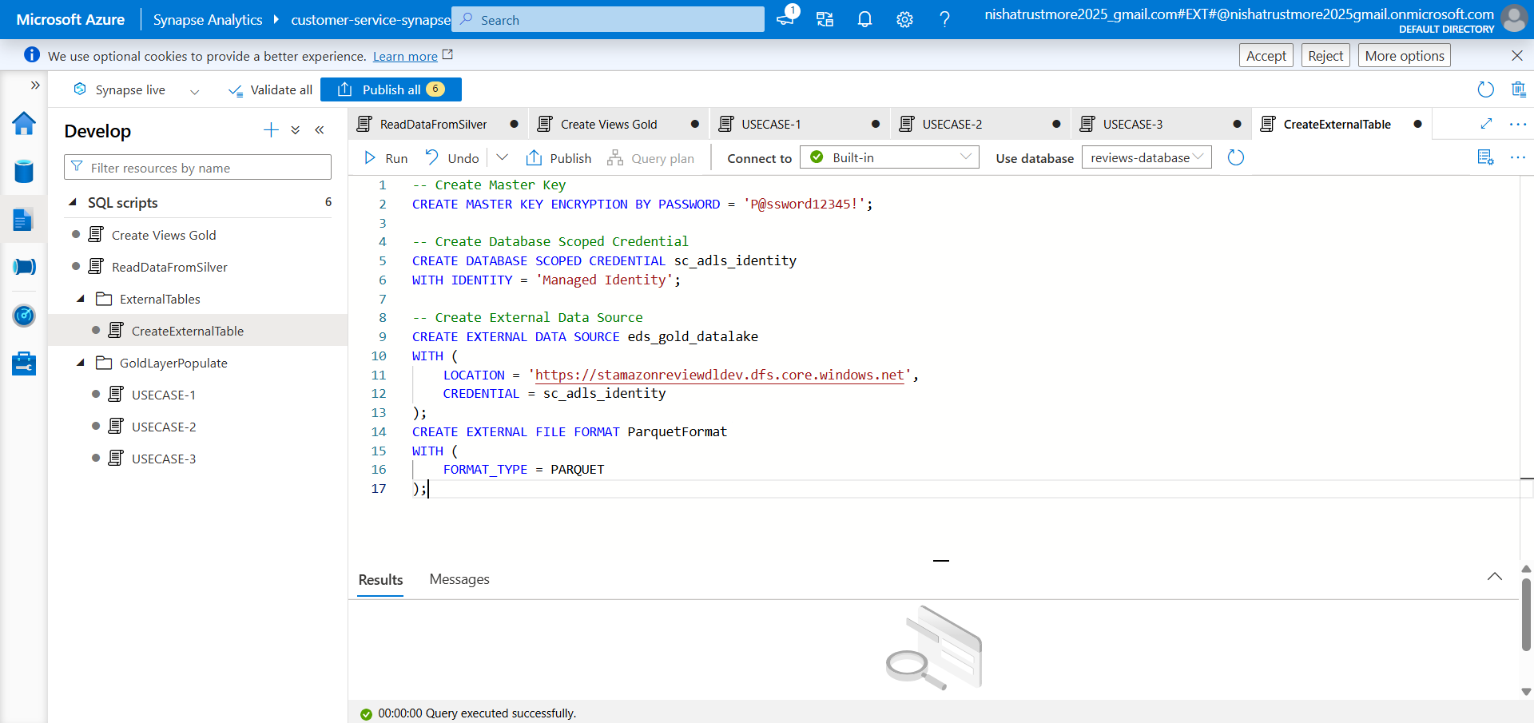

- Create a SQL script named ExportUseCase-1 and write the SQL query to create an external table and store the output data in the Data Lake.
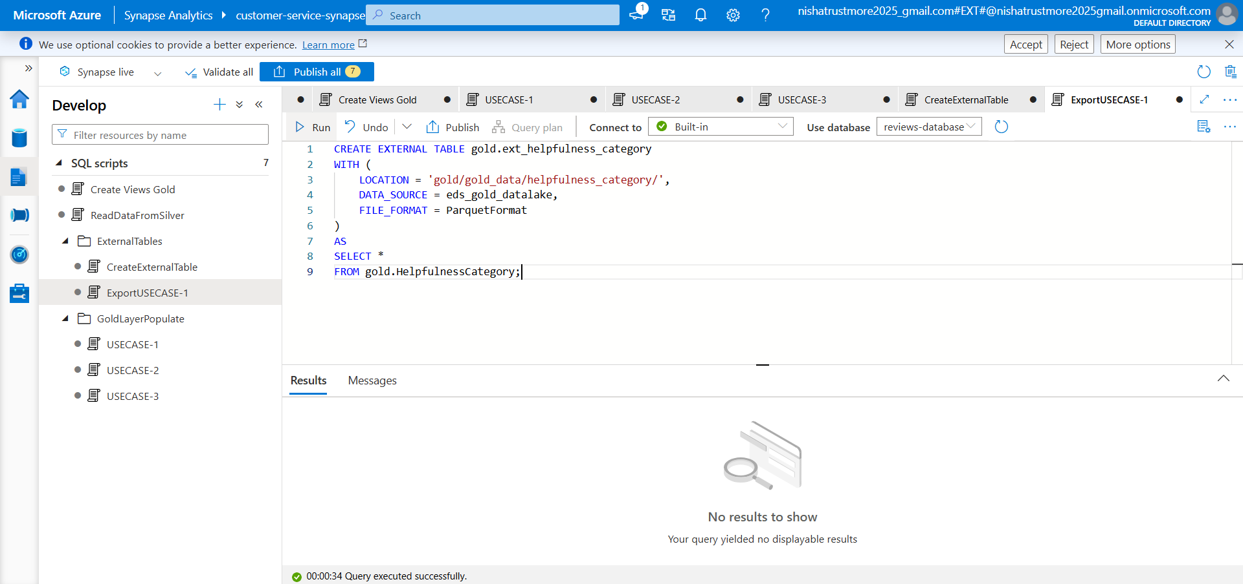

- Create a SQL script named ExportUseCase-2 and write the SQL query to create an external table and store the output data in the Data Lake.
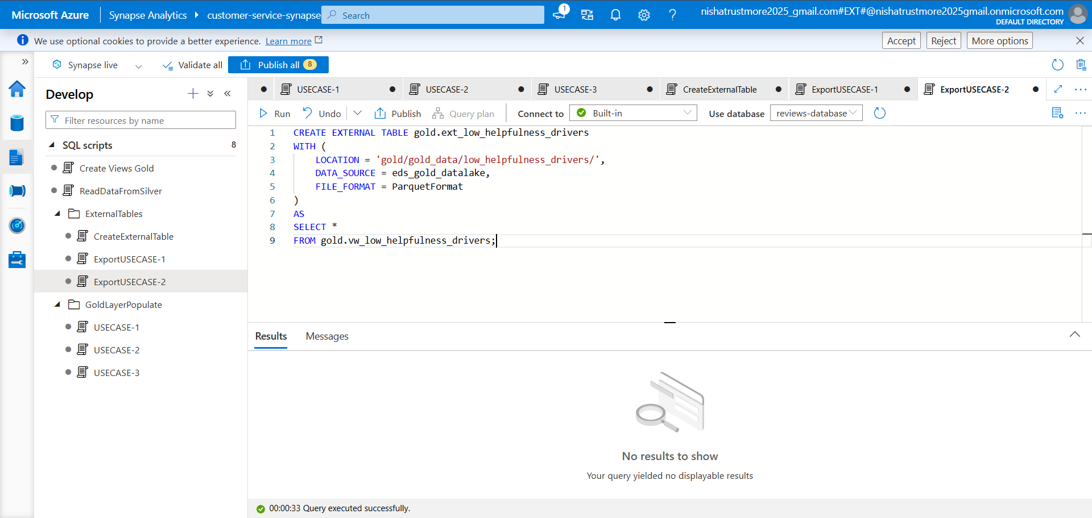

- Create a SQL script named ExportUseCase-3 and write the SQL query to create an external table and store the output data in the Data Lake.
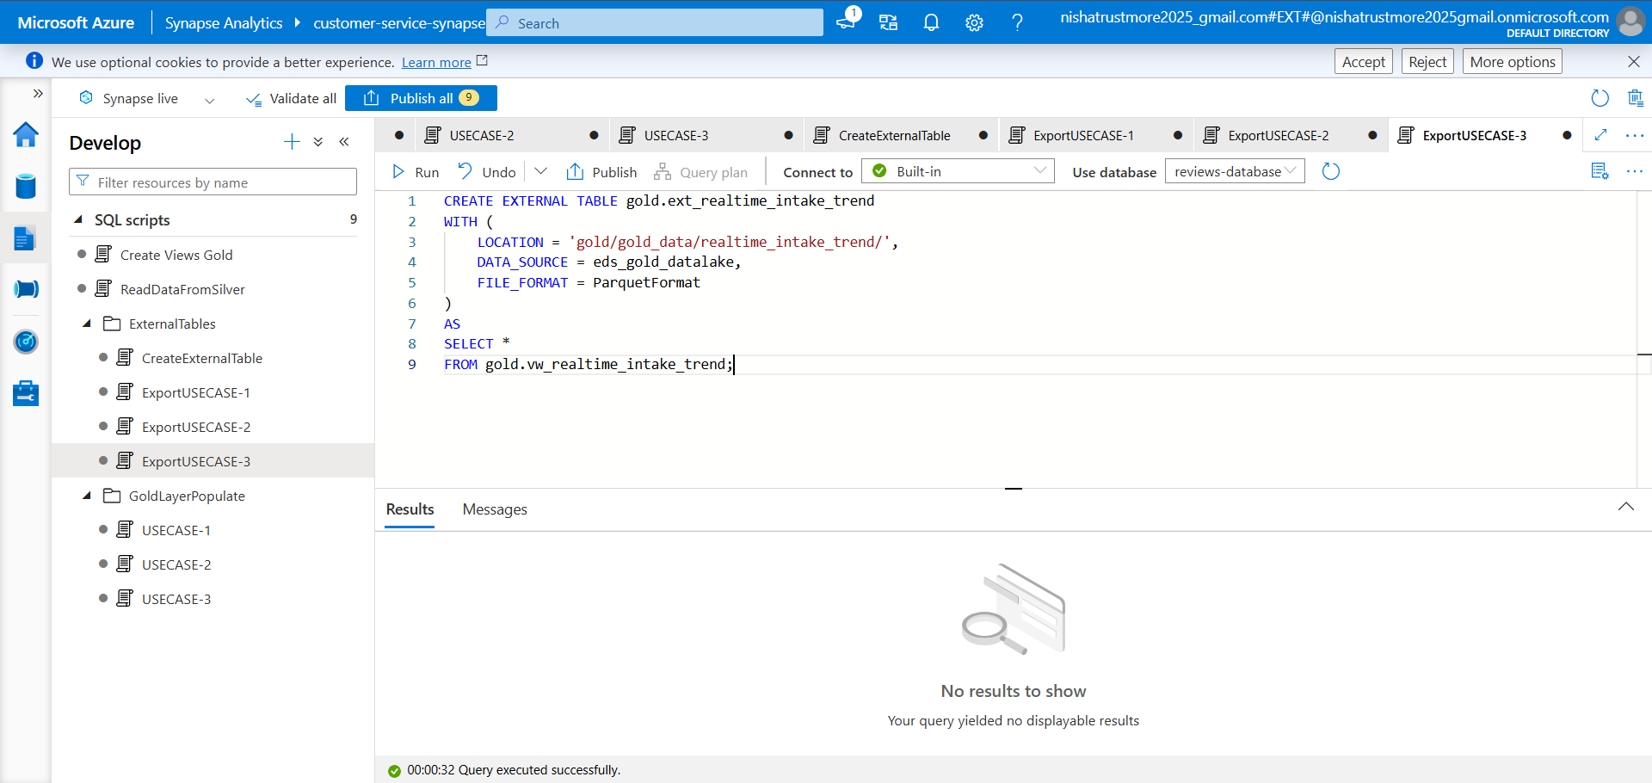

- The output data for all use cases is successfully stored in the Gold container of the “stamazonreviewdldev” storage account in Parquet format.

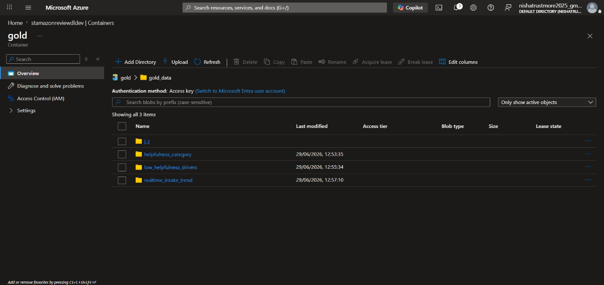

POWER BI

Step 1: Connecting Power BI to Azure Synapse Analytics.
- Open Power BI Desktop and click Get Data.
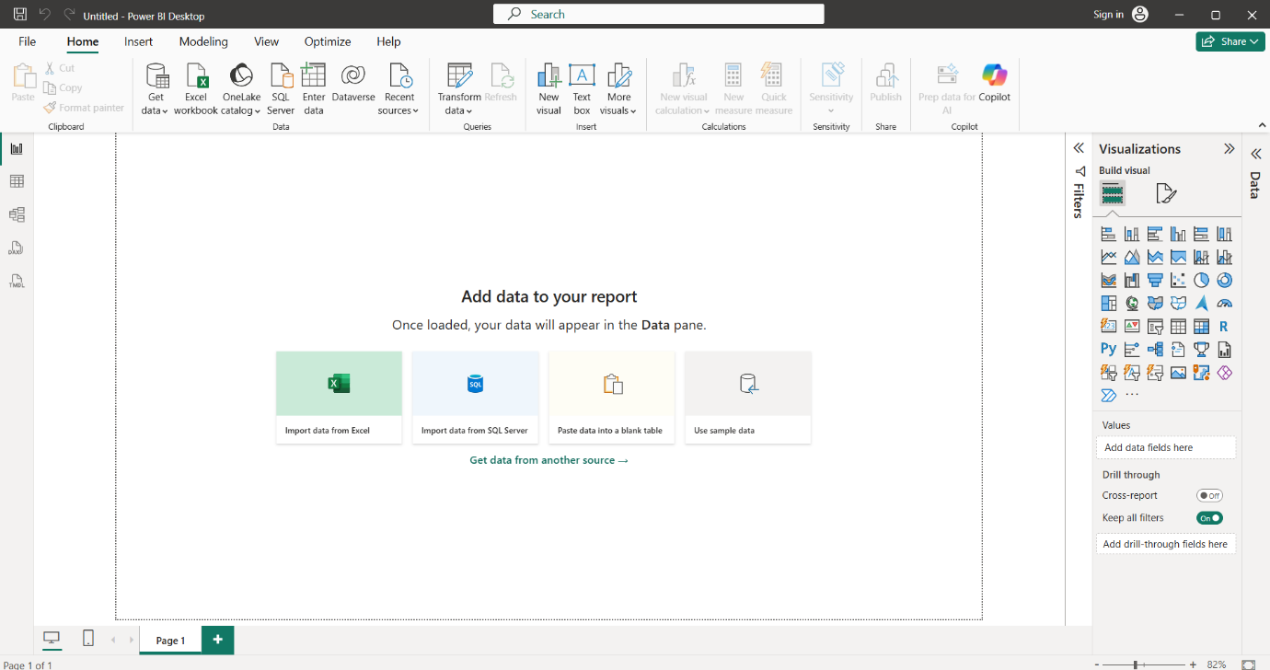

- Go to the Azure tab, select Azure Synapse Analytics SQL, and click Connect.
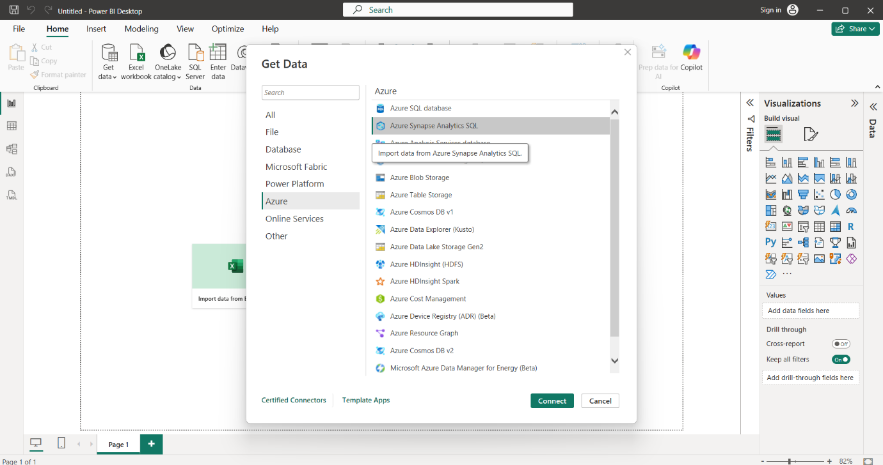

- Go to the Azure Synapse Analytics workspace, copy the Serverless SQL endpoint, and use it to establish the Power BI connection.
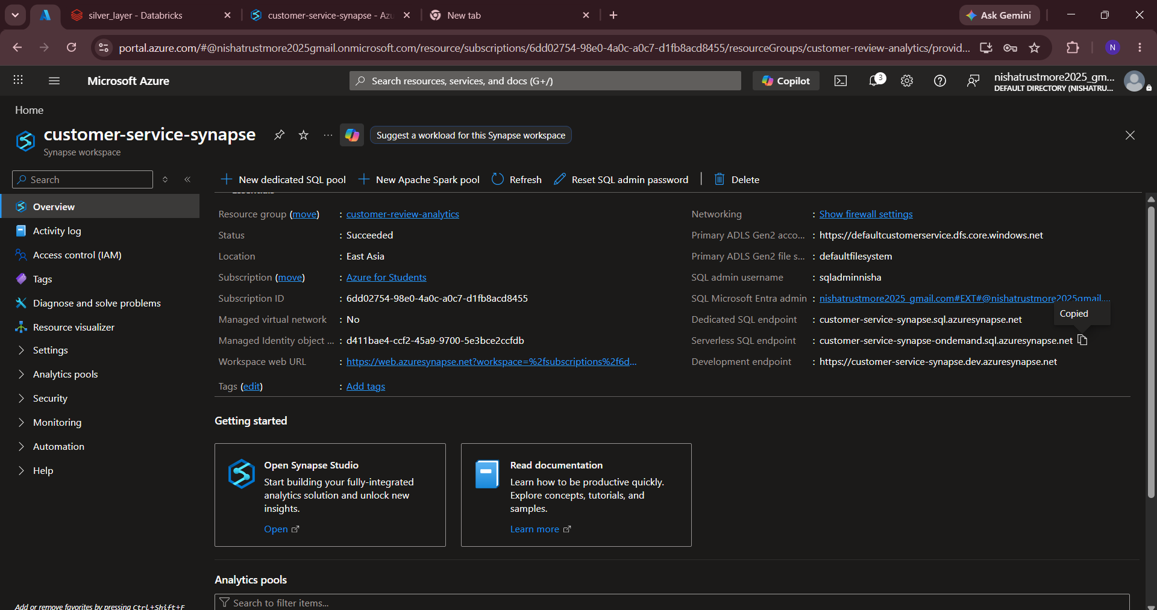

- Paste the Serverless SQL endpoint into the server field and click OK.
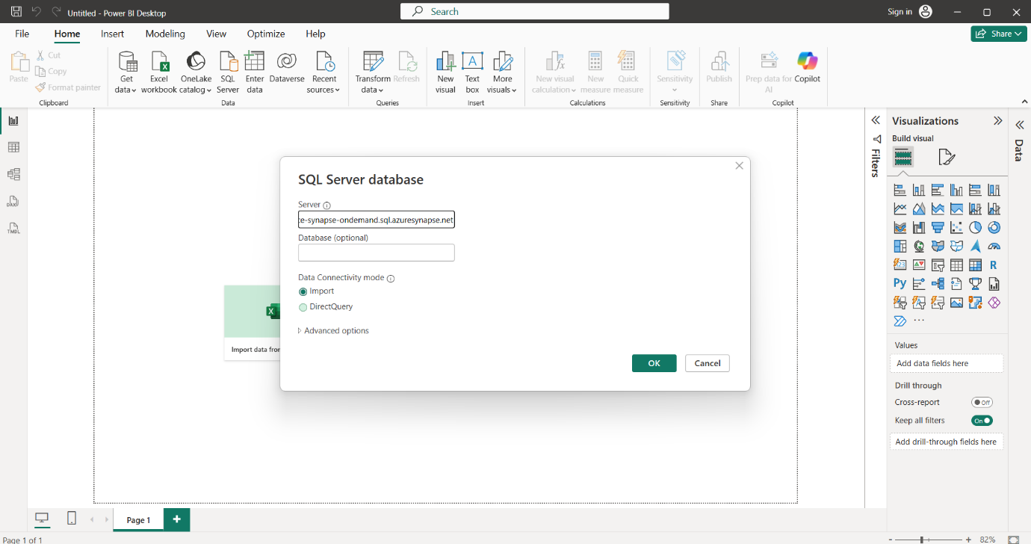

- Paste the Serverless SQL endpoint, enter the SQL Server administrator username and password configured during the Azure Synapse Analytics workspace setup, and click Connect.
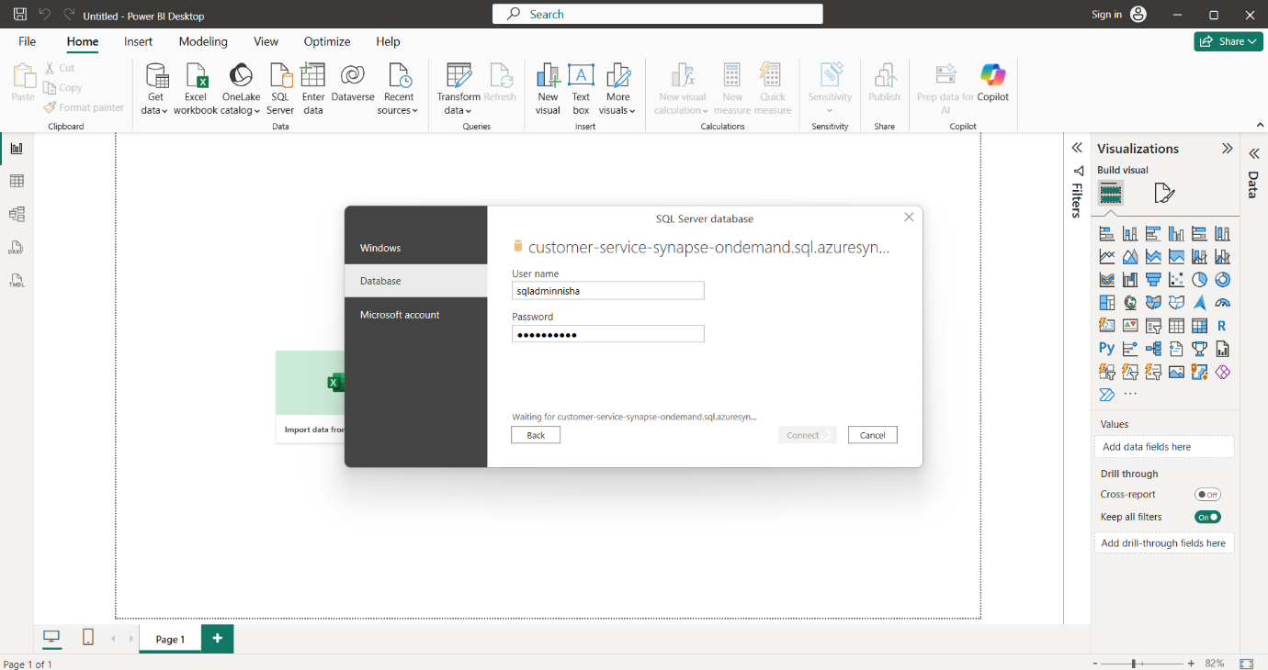

- After successfully connecting to Azure Synapse Analytics, select the required tables, click Load, and use the imported data to create the required Power BI visualizations.
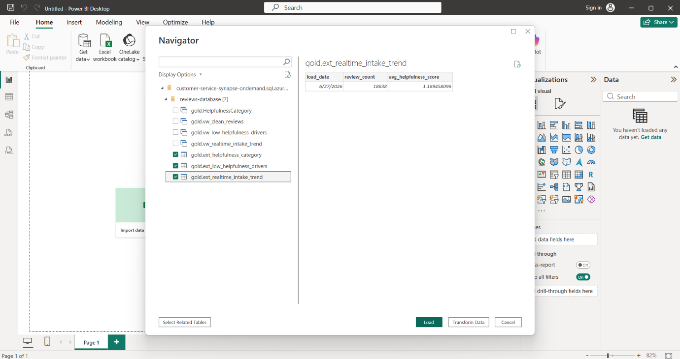

Step 2: Business Logic Visualizations.

Graph 1 :- Review Distribution by Helpfulness

Business Insight :-
Visualize the distribution of customer reviews across different helpfulness categories (Low, Medium, and High) to understand the overall quality of customer feedback.
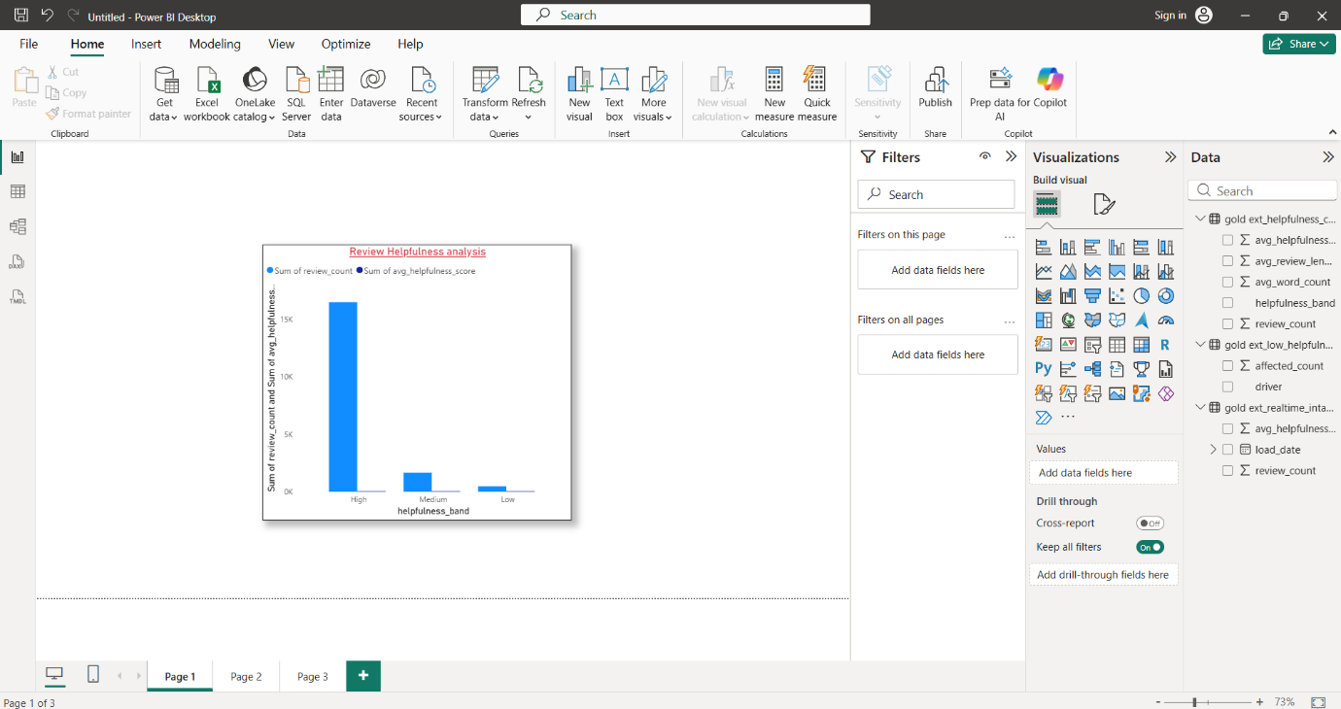

Graph 2 :-Word Count Distribution by Helpfulness Category

Business Insight:
The visualization highlights the most frequent low-helpfulness drivers, enabling businesses to identify areas for improving customer review quality.

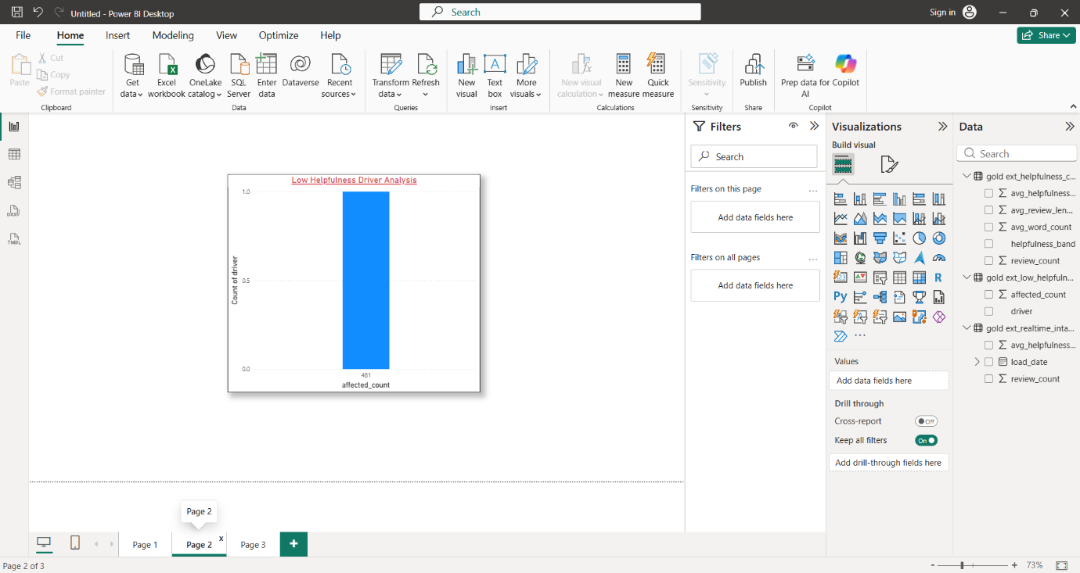

Graph3: Real-Time Intake Trend

Business Insight:
The visualization enables businesses to monitor review trends over time, helping identify changes in review volume and overall feedback quality for better decision-making.

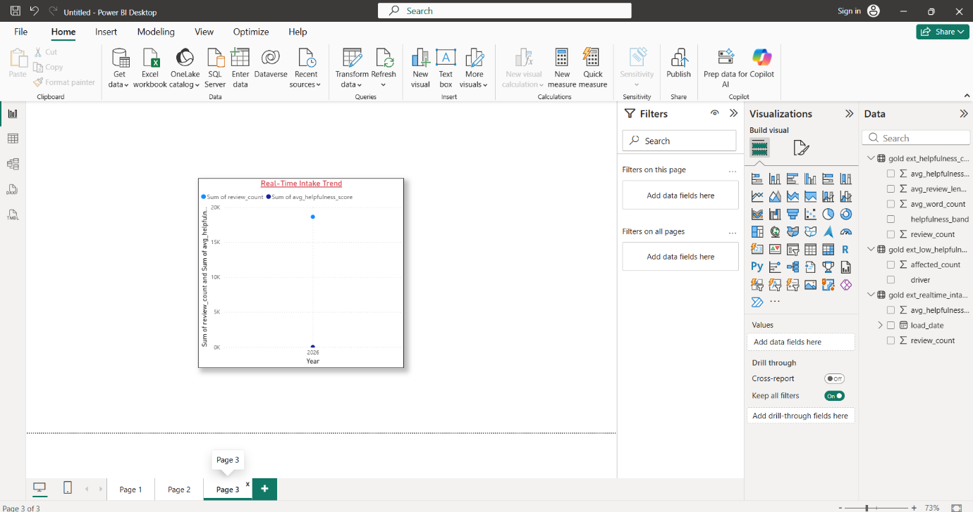

Power BI Visualizations (All Graphs in Desktop)

